**Automotive Manufacturing Automation**

Project Proposal

**EMGT 5220: Engineering Project Management**

**Spring 2024**

**Team 2: A-Team**

**TEAM MEMBERS**

BOKKA HARISH

CHAVAN RUTURAJ

DESHMUKH JAYENDRA

PATEL KUSH

PATIL MANSI

SHARMA SANYAM

VAIRAGADE AAYUSHIE

VITTAL BHARATH

**Teams Point of Contact**

PATEL KUSH

+1 (857) 753-7810

[patel.kush5@northeastern.edu](mailto:patel.kush5@northeastern.edu)

TABLE OF CONTENTS

LETTER OF TRANSMITTAL ii

EXECUTIVE SUMMARY iii

1.0 INTRODUCTION 1

1.1 Problem 1

1.2 Solution 1

2.0 PURPOSE AND OBJECTIVES 3

2.1 Purpose 3

2.2 Objectives 3

3.0 TECHNICAL OVERVIEW 4

3.1 Welding Workstation 4

3.2 Bodyshop Workstation 7

3.3 Windshield Assembly Workstation 9

3.4 Tire Assembly Workstation 12

3.5 Control Room Overview 15

3.6 Safety Design Overview 15

3.7 Testing and Evaluation 15

3.8 Site Plan and Placement 16

4.0 IMPLEMENTATION PLAN 17

4.1 Work Breakdown Structure 17

4.2 Schedule 17

4.3 Responsibility Chart 17

4.4 Resource Allocation 18

4.5 Stakeholders 18

5.0 Execution Plan 20

5.1 Project Monitoring 20

5.2 Project Control 21

5.3 Project Auditing 23

5.4 Project Closure 24

6.0 Risk Assessment Management Plan 25

6.1 Identification and Analysis of Risks 25

6.2 Project Risk Register 26

7.0 FINANCIAL PLAN WITH BUDGET 30

8.0 TEAM CREDENTIALS 32

APPENDICES 34

APPENDIX A: Work Breakdown Structure 34

APPENDIX B: Project Schedule 38

APPENDIX C: RACI Matrix 43

APPENDIX D: Financial Budget 48

APPENDIX E: Resource Allocation 51

# **LETTER OF TRANSMITTAL**

Date: 04/10/2024

Prof. Sharad Bajracharya  
Northeastern Graduate School of Engineering  
130 Snell Engineering  
360 Huntington Avenue  
Boston, MA 02115

Dear Prof. Sharad Bajracharya,

I am pleased to present you with the project proposal for the implementation of automotive manufacturing automation at our production facility. This project aims to address the challenges posed by manufacturing latency, errors, and labor dependency that currently impact our operations.

The proposed initiative involves the installation of robotic systems across key workstations, including welding, painting, windshield installation, and tire assembly areas. This transformative change will enable our manufacturing plant to operate at higher production rates while significantly reducing wastage caused by human errors. Furthermore, the automation of these critical processes will lead to improved product quality, thereby driving increased demand and shorter delivery times.

We hope that this proposal presents a compelling case for implementing automation across our automotive manufacturing processes. We appreciate your valuable feedback and guidance throughout this course, which enabled us to develop the necessary project management skills and apply them effectively in crafting this project.

Sincerely,

A-Team  
Bokka, Harish

Chavan, Ruturaj

Deshmukh, Jayendra

Patel, Kush

Patil, Mansi

Sharma, Sanyam

Vairagade, Aayushie

Vittal, Bharath

# **EXECUTIVE SUMMARY**

This automation project aims to tackle problems faced by the automotive industry during the production phase. The project’s primary objective is to reduce manufacturing latency, errors and labor dependency which directly affects the company’s financials. The four major key phases of this project are – designing, execution, testing & commissioning.

Before the designing phase, a project team is formed to lead the project and identify key parameters. Stakeholders are finalized and the scope of the project is clearly defined. The project tackles the primary issues in the welding, body shop, windshield & tire assembly area. These areas are studied and analyzed for possible automation which subsequently becomes the goal of the project. This analysis is then presented for approval to the stakeholder committee ensuring the project is headed in the right direction.

The design phase of the project is led by a team of engineers from domains like mechanical, robotics, electrical, HVAC and safety. The design team works on building a layout that can automate the selected workstations using the help of robots and integrate them into the pre-existing conveyor belt.

Using engineering practices and a structured project management approach, the work breakdown structure is divided into initiation, planning, designing, execution, and commissioning. To track and control the tasks listed under the WBS, a Gantt chart is prepared. The chart lists necessary details like the start date, end date and days assigned to each task to ensure the project progresses in the correct direction. To accommodate unforeseen delays each task is carefully assigned a buffer period to ensure the project end date does not deviate from the anticipated date. A RACI matrix is created to outline the expectations of each stakeholder clarifying roles and eliminating the scope of confusion. The project team consists of project manager, mechanical manager, robotics manager, electrical manager, civil manager and hiring manager. Execution of the project is the longest phase involving procurement, installation, civil work, and peripheral jobs. Upon successful completion of the execution phase, an extensive testing phase begins which prepares the new set-up for a full capacity production and detects all possible operational defects. Upon completion of the evaluation process, a testing report is generated which in turn provides the feasibility of project handover. An operation team is formed and trained to take over the new setup. An extensive ‘standard operating procedure-SOP’ document is created highlighting the operational details and maintenance of robots in the new automation environment. The final phase of the project involves closure, auditing, & termination. A fact-checking of all purchased goods and built structures is done for financial records.

The project spans over 556 days with a capital expenditure of ~$26 million to reposition the company in the market again. The project aims to increase the production rate to re-capture the market loss due to long delivery times and meet the new demands based on a higher quality product. With this project plan, the company aims to achieve an 8.5% profit margin to compete with the market demand and deliver a product with the least possible manufacturing defects.

# **1.0 INTRODUCTION**

## **1.1 Problem**

Traditional automotive manufacturing plants relying on manual labor across processes like welding, painting, and assembly faced significant drawbacks impacting quality, costs, and productivity. The welding process, which is essential to maintaining structural integrity, is hampered by flaws including undercutting, excessive spatter, and porosity when done by hand. Due to these weld flaws, whole metal components were frequently destroyed, resulting in significant material waste and monetary losses.

The paint shop struggled with issues such as uneven coating, overspray causing hazardous waste, and poor finish quality from manual operations. Human workers face health risks from exposure to paint fumes and ergonomic stresses.

For assembly tasks like windshield installation, manual processes were error-prone, resulting in misalignments, leaks, and potential safety hazards. These defects increased rework rates, warranty claims, and costs.

Furthermore, the industry faced a severe shortage of skilled welders, with a projected demand for 300,000 additional professionals by 2024 in the U.S. alone[1]. Overreliance on manual labor constrained production volumes and escalated costs.

## **1.2 Solution**

The concept suggests combining sophisticated robotic automation systems across several assembly line stations to fully address these issues. Precise single-arm industrial robots will be used at the welding stations to execute extremely exact and consistent welds, reducing flaws. This lowers cycle times and material waste from discarded welds, improving the structural integrity of assembled components.

For painting, automated robots optimize coating thickness, minimize overspray, and deliver superior finish quality. This significantly reduces paint usage by 0.5 liters per vehicle[2], disposal costs, and eliminates operator exposure to fumes.

In assembly, robotic arms provide exceptional repeatability for tasks like windshield fitting and wheel mounting, applying controlled force to eliminate misalignments. This minimizes rework, warranty claims, and boosts throughput by up to 25%.

Across all processes, robotic automation enhances workplace safety by eliminating hazardous tasks for human workers, reducing incidents by 72%. It also helps mitigate labor shortages by optimizing workforce deployment while meeting production demands.

While the initial investment might seem high, robotic systems payback period is relatively short, considering substantial improvements in quality, productivity, material usage, and operating costs[3].

By integrating robotics across manufacturing operations, automotive companies realize significant cost savings from quality enhancements, reduced scrap/rework, and optimized materials usage. Robotic automation also delivers strong productivity gains, higher throughput, better workplace safety, and combats labor challenges – providing a comprehensive upgrade over manual processes.

Our comprehensive approach to addressing the root causes of issues in car manufacturing assembly lines focuses on implementing a combination of advanced automation tools and meticulous planning to tackle each stage of the production process, from welding to painting and assembly. Additionally, our project prioritizes safety and efficiency, aiming to minimize errors and waste while maximizing productivity. We have identified key areas for improvement, such as addressing defects in welding and painting processes, and have developed strategies to mitigate risks and ensure optimal performance. Overall, our project represents a comprehensive and innovative approach to car manufacturing, offering hope for success where others have encountered difficulties.

# **2.0 PURPOSE AND OBJECTIVES**

## **2.1 Purpose**

This project aims to improve the automotive industry by addressing critical challenges identified through extensive analysis[4],[5]. Leveraging the potential of Industry 4.0[6], it seeks to eliminate inefficiencies and errors present in manual processes such as welding, painting, windshield, and wheel installation. The primary focus is on enhancing accuracy, reducing material wastage, and optimizing production cycles using advanced automated solutions. Additionally, the project prioritizes sustainable practices, leading to decreased operational costs, minimized carbon footprint, and improved overall competitiveness in the automotive industry.

## **2.2 Objectives**

* With this project we aim to leverage robotic automation to eliminate human errors on the manufacturing line and the associated costs incurred due to them. Additionally, it aims to reduce dependence on manual workforce and mitigate potential issues arising from union strikes and labor shortages, resulting in an estimated 20% cost savings.
* The secondary objective is to increase task efficiency by 30% to boost production rates and meet growing market demands.
* The tertiary objective of this project is to improve the overall quality of production by leveraging robotic technology to ensure consistent and precise manufacturing processes, leading to higher customer satisfaction and brand reputation.
* The quaternary objective of this project is that we wish to improve our profit margins up to 8.5% which is the industry standard. is that the benefits arising from
* Ultimately, this project aims to streamline the automotive manufacturing industry by using automated processes to make it more efficient, cost-effective, and reduce the environmental impact caused by the process.

# **3.0 TECHNICAL OVERVIEW**

## **3.1 Welding Workstation**

**Current Setup**

The Factory operates on a manual Metal Inert Gas (MIG) welding setup on the conveyor belt. The welding team consisted of 12 welders in a single shift assisted by a team of 12 helpers. The process involves a welder using a Miller 350 delta welding machine to weld joints in a pre-specified zone on the chassis. Each welder is assigned a zone depending upon the welder’s location with respect to the chassis at the workstation. On average the welder spends roughly 1.5 to 2 hours on a single chassis to weld all spots. This time includes any sort of rework or fixing errors that may have occurred. There are twelve such teams of welders and helpers, six on either side of the conveyor belt.

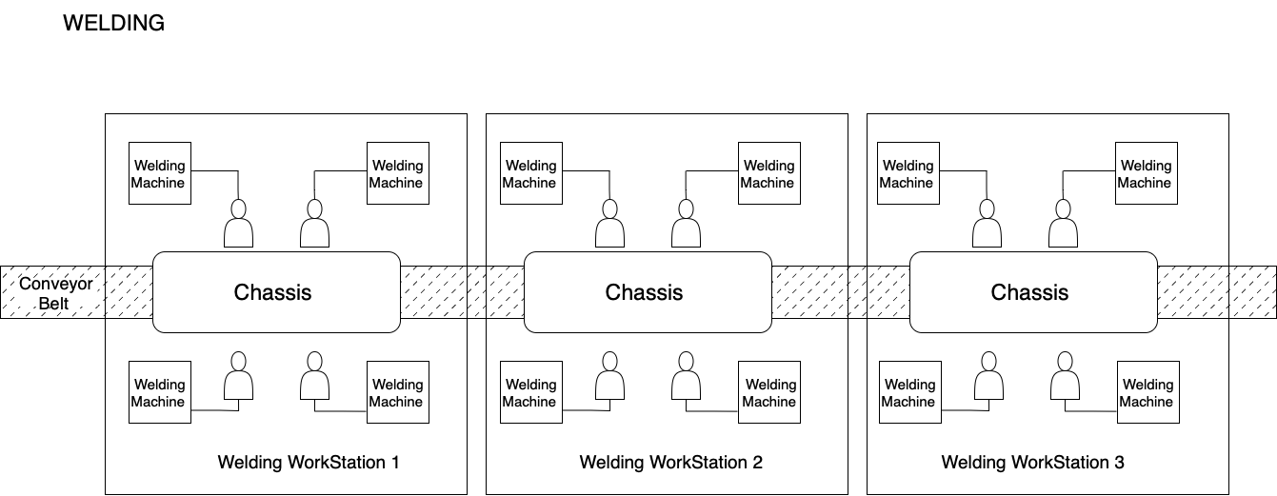

*Visual representation of old layout for manual welding*

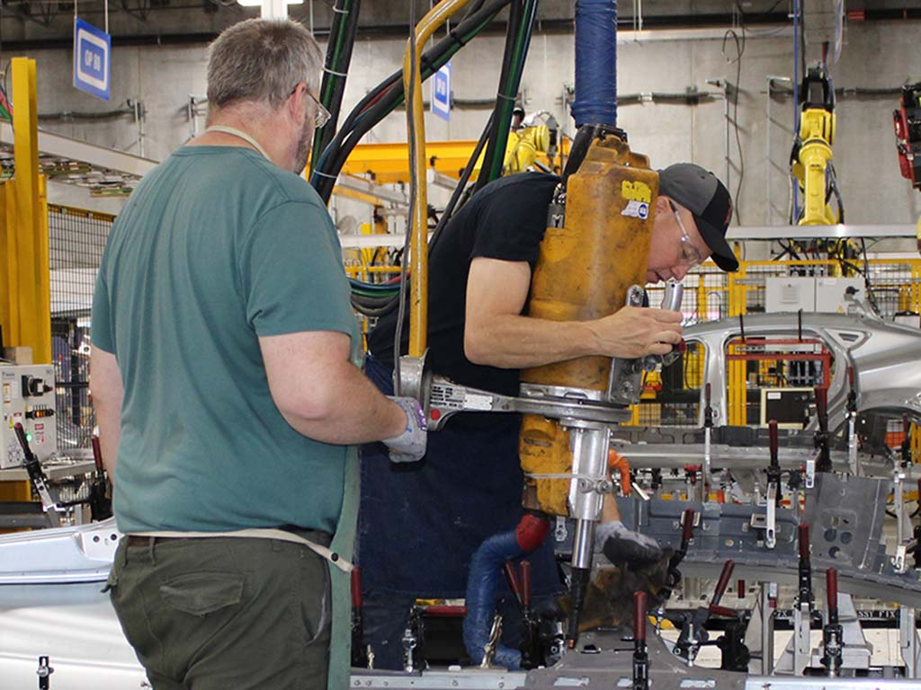

*This image highlights the hassle of manual welding (Source: Google Images)*

**Projected Setup**

The Automation plan of the welding station will involve renovating the area by replacing the 12 manual teams with 6 welding robots. The plan involves placing the robots in a way that the pre-existing conveyor belt is not disturbed. This will ensure that the current manufacturing process does not undergo major modifications due to automation in a single area. The six robots selected for this process are **Motoman MA1400**[7]. The robots can perform MIG welding operations superior to that of a traditional Welder using a 350 Miller delta MIG machine.

The robot will be placed on a civil structure right next to the existing conveyor belt. The structure is placed at a safe distance from the belt ensuring that the robot’s welding end can easily cover all the welding points on the chassis that are assigned to it. These robots will be fixed onto the civil structure using bolts that secure it to the base. The robot employs a 400-amp MIG welding attachment that comes with the package. The tip of the robotic arm can reach all simple yet intricate locations on the chassis. The welding wire and gas need to be refilled after every 6 to 7 chassis are completed. This process will be done by a technician that is stationed in the area. One technician will be responsible for refilling three robots. Two such technicians will be trained and stationed for this job. All automated operations will be controlled and monitored by a robotics engineer stationed inside a control room. This control room is placed at an overlooking distance and can control all aspects of the welding workstation.

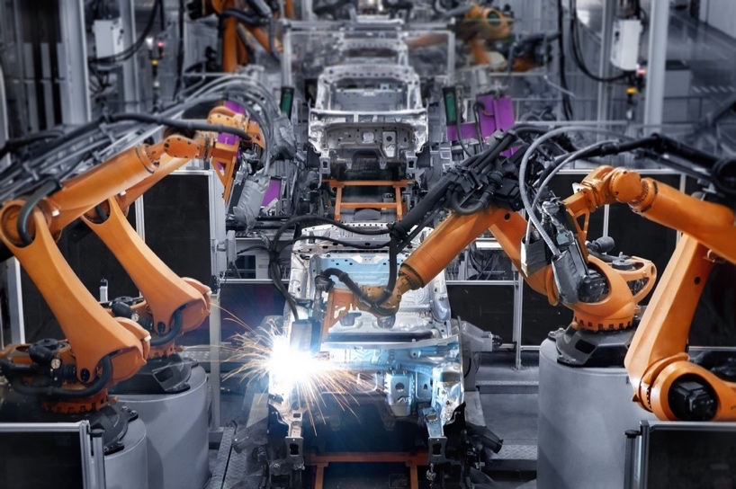

*This image displays the welding procedures performed with the help of robots (Source: Google Images)*

As the chassis arrives at the welding station, an **XUM Miniature Photoelectric Sensor**[8] prompts a signal to the control room and prepares the robot for welding operations. The robot retracts to an initial position allowing the chassis to move towards the target location. The target location of the chassis will allow the robot to seamlessly reach all weld points.

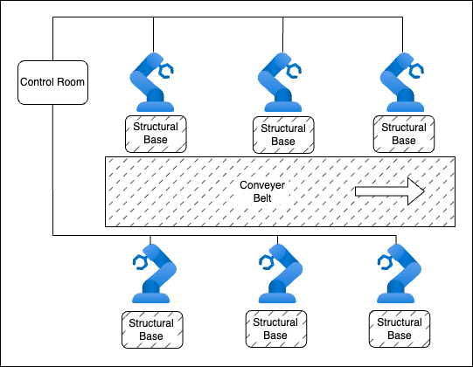

*Visual representation of projected welding workstation layout*

## **3.2 Bodyshop Workstation**

**Current Setup**

The Bodyshop workstation is operated with the help of manual workers applying different coats at different paint booths. The team consists of 6 paint technicians stationed at 3 separate booths where they operate handheld spray guns for applying the coats on the vehicle body parts. The paint setup consists of 6 pressure spray guns with 2-quart (1893cc) pressure pot and 1.2 mm tip which are operated manually by the technicians. These spray guns consist of a paint chamber that can hold 2 quarts of paint and a variable pressure capacity between 5-20 PSI. These handheld guns have a 6 ft. air hose and a 6 ft. fluid hose which is connected to the gun for a longer reach. The process of painting is such that, as soon as the vehicle part arrives at the first booth, a coat of primer is applied by 2 technicians using the spray guns. Upon completion, the conveyor belt moves forward for the 2 separate coats of paint at the following paint booths which are completed by 2 technicians at those workstations respectively.

During this process, the technicians must mix the paint manually and make sure that the paint ratio remains consistent throughout. They also must make sure that while applying the coat they do not paint a particular area too many times which might result in paint sagging and color variation. As soon as all the 3 processes are completed the conveyer belt moves forward for the drying process followed by paint inspection.

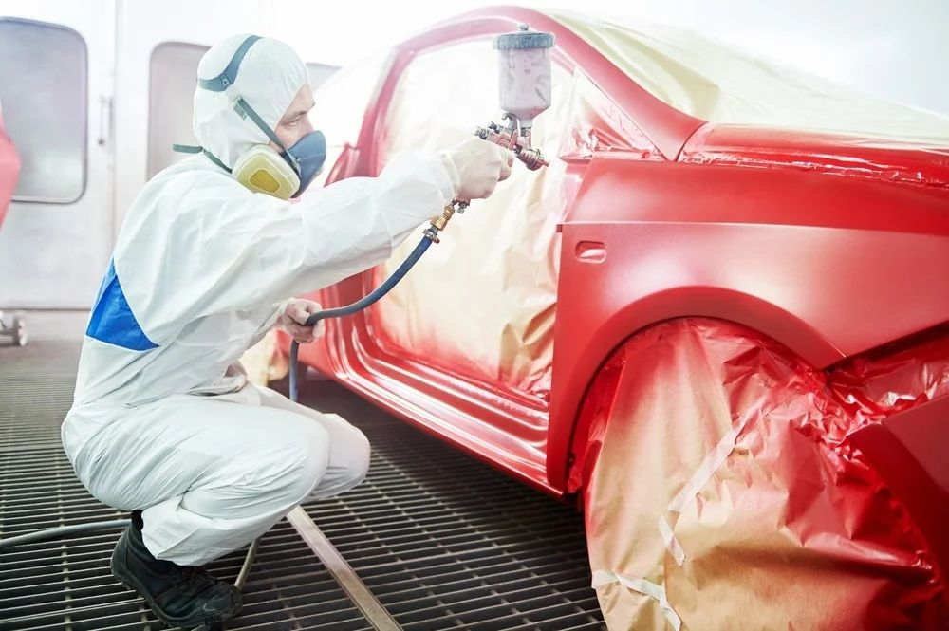

*This image highlights the manual Bodyshop procedure (Source: Google Images)*

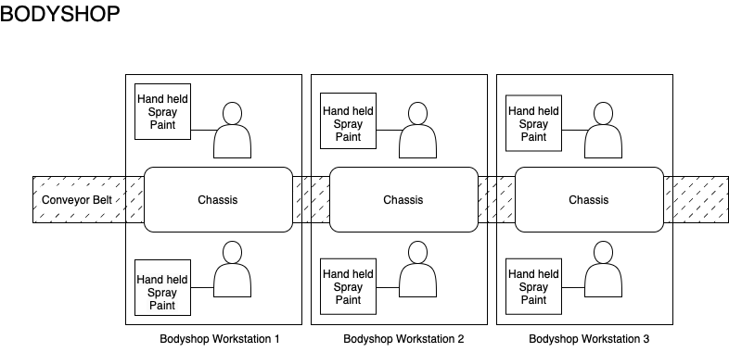

*Visual representation of old layout for manual body shop workstation*

**Projected Setup**

In the new setup a civil structure will be constructed at the 3 painting booths to accommodate 6 **FANUC P-250iB/15[9]** robots. The structure will be constructed in such a way that robots could move laterally along the length of the car individually at each workstation. 2 material flow ultra-sonic sensors (XUM Miniature Photoelectric Sensor) are installed at every workstation which ensure the synchronization between the conveyer belt and the robots. 2 FANUC robots will be installed at each paint booth respectively which are responsible for 3 separate coats of primer and paint which were earlier done manually. The robots are centrally controlled by **FANUC R-30iB[10]** controller which is in the control room situated adjacent to the workstation. A designated robotics engineer handles the robot’s operations, while two technicians handle the maintenance and control tasks. The **FANUC P-250iB/15** robots utilize FANUC's comprehensive software suite, including Robo guide for simulation and offline programming, alongside the **KAREL** programming language for custom logic programmed onto the **Teach Pendant Interface**.

The process of Bodyshop workstation is such that as soon as the vehicle chassis arrives at the first paint booth the robots are aligned with the chassis via the ultrasonic sensors. And the first booth applies a coat of primer on the part. Once completed the conveyer belt moves forward to the subsequent paint booths for the 2 separate coats of paint at the respective paint booths. Upon completion of the painting at the 3 workstations the conveyer belt moves forward for the drying process. The newly installed robots will be equipped with a paint chamber with a capacity of 30 liters where the paint must be filled by the technician, but the mixing of the paint is completed automatically by the robots. This ensures that the paint ratio is consistent throughout the assembly. By using robots for the paint application, the coats remain even and overcomes the issue of paint sagging and uneven coats. For the electrical installation of the **FANUC R-30iB** controller and **FANUC P-250iB/15** robots, the manufacturer recommends a **200-240V AC** power supply on a **3-phase** power outlet to provide balanced power input. The wire gauge and insulation should be suitable for the current ratings and environmental conditions. Grounding and circuit protection requirements will also be met as per the FANUC guidelines. An emergency stop system will be installed to halt all six robots and the controller in case of any mishap, cutting the electricity supply to all the robots. It is necessary to ensure that all the robots operate within the specified temperature limits to maintain optimal performance. The robots come equipped with UPS systems that prevent sudden interruptions due to power outages, but these systems are designed for aiding proper system shutdown and do not last for extended periods.

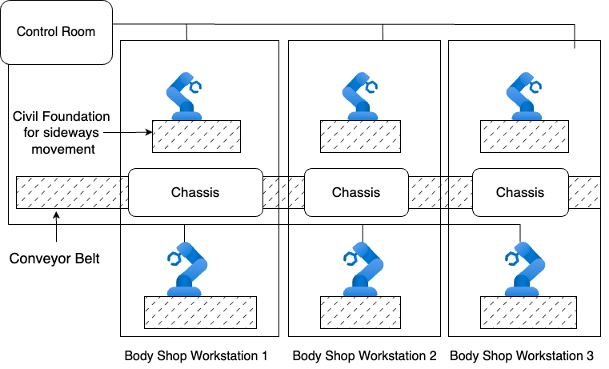

*Visual representation of projected body shop workstation layout*

## **3.3 Windshield Assembly Workstation**

**Current Setup**

The current windshield workstation setup has six manual laborers – two for applying the sealant on each side of the chassis and four laborers to load the windshields using suction cups (two on either side).

The windshield setup consists of two caulking guns with V-shaped nozzle to manually apply urethane. The two technicians responsible for sealant application first apply primer along the inside edge of the window and apply primer to the windshield socket as well and let it dry. In the next step they apply urethane throughout the entire frame, quickly to prevent it from drying, using a V-shaped nozzle to help the urethane sit higher forming a better seal with the windshield.

It is followed by two technicians carrying each windshield with suction cups attached and push it firmly into the vehicle. This is installed rapidly on the vehicle before the urethane dries out. In this process, the technicians must make sure the sealant is applied uniformly.

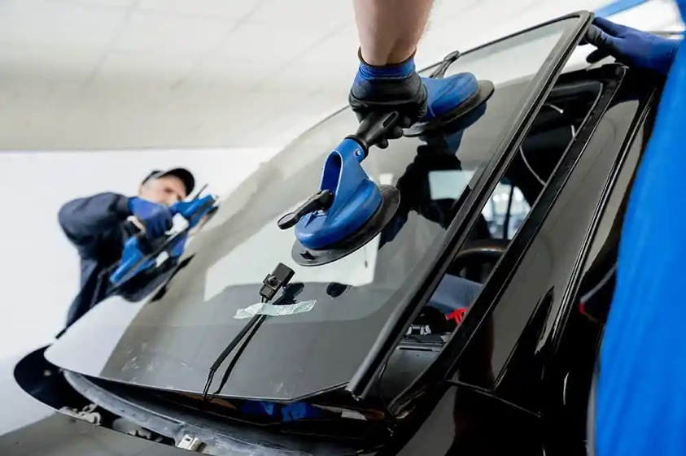

*This image highlights the manual windshield installation (Source: Google Images)*

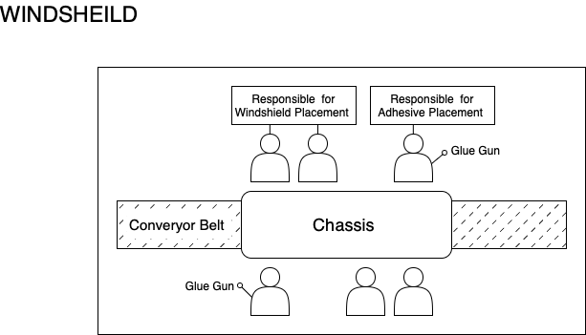

*Visual representation of old layout for windshield assembly workstation*

**Projected Setup**

The new setup includes the construction of an overhanging structure to install two **FANUC R-2000iB/200T** **top loader robots[11]** and one **M-710iC/50T** **top loader robot[12]**. The **M-710iC/50T** robot with a reach of 1900 mm is responsible for glue application, which is installed to move laterally alongside the structure to ensure glue is applied on either side of the vehicle. The other two robots are installed on either side of the railing to lift and install windshields on either side of the vehicle. This 3-robot setup replaces six manual laborers and increases production efficiency and reduces errors. Two material flow ultra-sonic sensors (XUM Miniature Photoelectric Sensor) will be installed at the workstation which ensures the synchronization between the conveyer belt and the robots. The robots are controlled by a **FANUC R2000iB** controller from the control room, which is operated by a robotics engineer who will handle all three robotic operations. These robot models are integrated into FANUC's own offline programming software, **ROBOGUIDE.**

The windshield installation process starts with the chassis moving to the workstation which is detected by ultra-sonic sensors and notifies the control unit. The control unit outputs a signal to control the gluing robot **M-710iC/50T** which moves along the front end of the vehicle and applies the glue across the entire frame, followed by moving to the rear end and applying the glue across the rear window frame, in response to the signal. After the glue application, the visual unit positions the windshield for proper installation and sends the recognition signal to the **FANUC R-2000iB/200T** robots through the control unit. The windshields are stored in the placement racks by the technician. In response to the signal from the control unit, the robots lift the windshield using suction cups from the placement racks assembles them on the vehicle. The robotic windshield assembly process ensures uniform application of the sealant and accurate positioning of the windshield, eliminating the potential for human error, improper sealant application or accidental breakage of windshield during manual installation.

For the windshield assembly automation, we'll be following the electrical specs provided by FANUC for their controller and robot models. We need to set up a 3-phase 200-240V AC power line to feed balanced power to the whole system. The wiring must be properly sized and insulated based on the current draw and environment in that area of the plant. Grounding and circuit protection will be done exactly as FANUC outlines in their installation manuals. Safety is a top priority, so we're installing an emergency stop setup that can cut power to all three robots and the controller immediately if any issues come up. The robots obviously must operate within their temperature limits for consistent performance, so we'll be monitoring that closely. The robots have built-in UPS backup, but that's just to allow a proper shutdown sequence if we have a power blip. It won't run the whole system for any length of time during an outage.

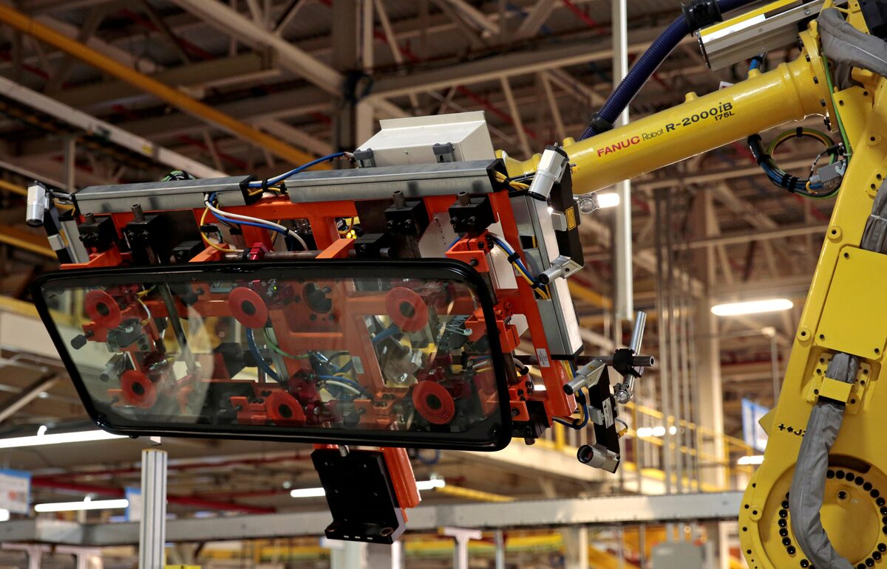

*This image displays the robotic windshield installation (Source: Google Images)*

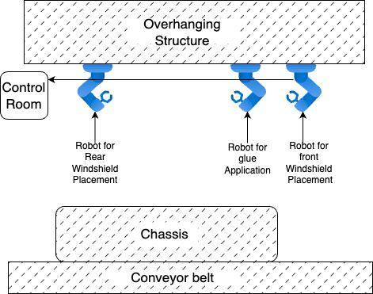

*Visual representation of projected body shop workstation layout*

## **3.4 Tire Assembly Workstation**

**Current Setup**

The tire assembly area is operated by a total of six manual workers who place and lock tires on the wheel hub in a sequential process. A set of two workers operate on single vehicle each assembling two tires onto the vehicle. This process is executed for three vehicles at a time. The placement of tire on the wheel hub is done by manual force which is time consuming and can have long term health issues for the worker. The bolting is done using a pneumatic bolting gun that overhangs from the ceiling on each side of the conveyor belt.

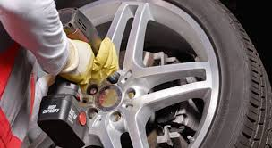

*A handgun bolting process to tighten the bolts on the wheel hub (Source: Google Images)*

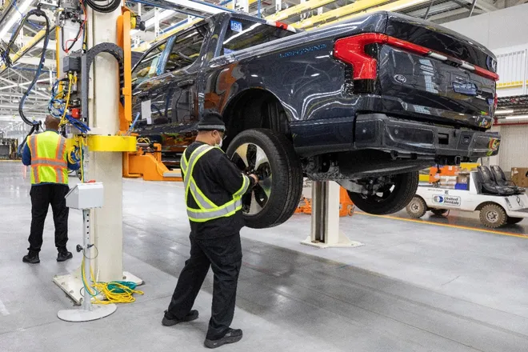

*Manual worker placing the tire on the wheel hub (Source: Google Images)*

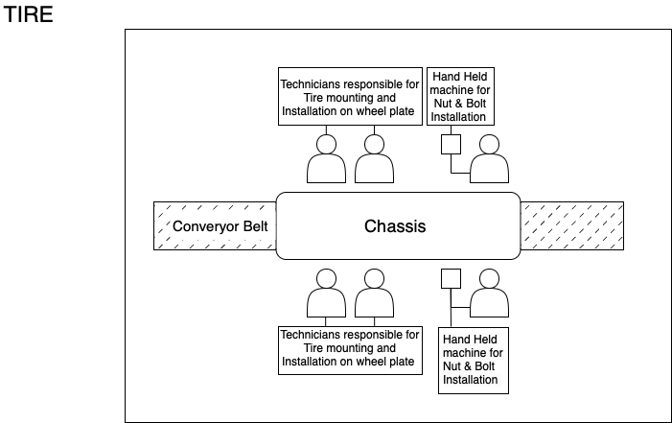

*Visual representation of old layout for tire assembly workstation*

**Projected Setup**

At the tire assembly area, we aim to reduce the production latency by replacing 6 manual workers using 3 robots. The robots selected for this process are **FANUC R-2000iC/210R[13]**. The first robot will be responsible for accurately placing the tire onto the wheel hub. Robot’s base is connected to a railing that allows lateral movement along the length of the car. The input motor that enables lateral movement is controlled from the control room. An ultrasonic sensor prompts the signal when the vehicle is approaching the robot’s proximity. A vision system that will be integrated with the robot’s hardware and software detects the four bolts on the wheel hub and accordingly moves the tire on its rotational axis to align with the bolts. The second robot employs a pneumatic gun on the robot’s arm-end that operates based on the inputs received from the vision system to bolt the tire on the wheel hub. A control room managed by a robotics engineer will monitor the assembly process on the robots using a preprogrammed software. The control room is equipped by a software that is compatible with the two robots and allows a central control for both. The central compressor that is placed besides the control room supplies sufficient pressure to both the robots that use a pneumatic gun. The combination of the four robots reduces the latency in this process making the process faster and more precise.

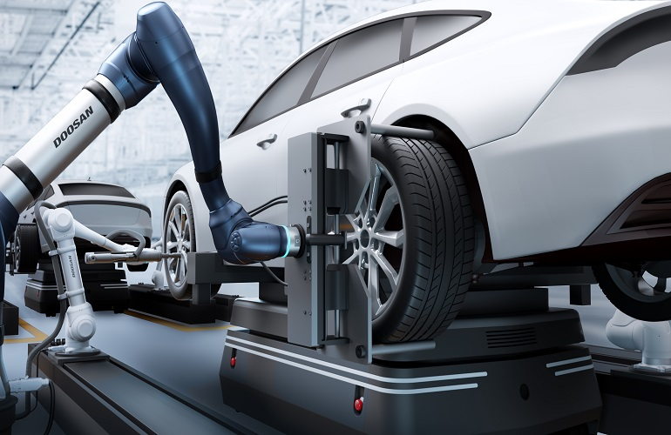

*A robotic arm aligning the tire onto the wheel hub (Source: Google images)*

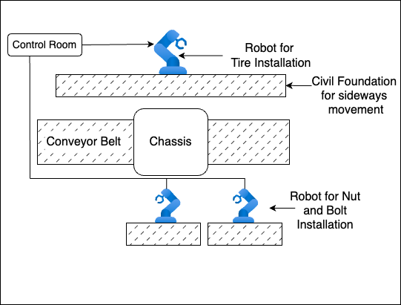

*Visual representation of projected tire assembly workstation layout*

## **3.5 Control Room Overview**

The central control will be used to monitor and keep track of all operations taking place on the assembly line. A skilled operations team will be stationed for continuous monitoring of the assembly line. This control room has a central **SCADA** system that gives visual representation and at the same time allows the operator to control the robot is deemed necessary. From the control center, the operators can monitor the real time data on the performance and status of the robotic systems at each workstation. In case of an issue the operations team will communicate with the maintenance team and the operators stationed at their respective workstations control rooms to collaboratively address the issue.

## **3.6 Safety Design Overview**

To maintain the safety of the working professionals few safety gears will be installed at every automated workstation, some of which include:

1. Personnel barriers
2. Access doors
3. Door switches
4. Awareness beacons
5. Control system interlocks
6. Signage

Safety standards will be taken into consideration as per the regulatory requirements set by American National Standard for Industrial Robots and Robot Systems[14], ISO Technical Specification[15].

## **3.7 Testing and Evaluation**

1. Upon placements of all robots, we will conduct test runs to verify performance and functionality.
2. Assessing welding precision, body panel alignment, windshield sealing, and tire mounting accuracy through rigorous testing.
3. Analyzing production metrics including cycle times, defect rates, and throughput efficiency to evaluate overall system performance.

## **3.8 Site Plan and Placement**

The engineering team will conduct a thorough site assessment to define the designated location for placing the robots. When planning the placement of the robots, all necessary conditions such as wiring harness placement, routing of electrical lines, placement of power outlets, and ventilation for maintaining optimum temperature will be considered. The layout of the entire plan will be designed to ensure accessibility for all users handling the equipment in the facility.

# **4.0 IMPLEMENTATION PLAN**

**4.1 Work Breakdown Structure**

The project WBS is mainly divided into 4 phases as detailed in *Appendix A*. Since the automation of 3 assembly lines is complete, most of the tasks for one assembly line are replicated for the other 2 assembly lines. These 4 phases are primarily project initiation, planning, execution, and closure. During project initiation, the team is assigned to the project, and the scope, business objectives, and timeline are determined. In project planning, the design of the MEC work required for every revamped line is completed. Once this is done, a procurement plan is created for all the raw materials. Later, workforce requirements are calculated, and hiring is carried out.

The project then moves to the execution phase, where the individual tasks such as construction, assembly, and connecting the robot to the electrical supply are performed. The robot is activated, and testing is conducted to check its functionality. Any errors or problems are documented to complete this phase. Finally, in the project closure phase, a review of the entire project is conducted, and stakeholders are asked to provide approval. Handover procedures are completed, and a final project review is shared with the team.

## **4.2 Schedule**

The project team has leveraged Microsoft Project to develop a comprehensive communication plan, detailed in *Appendix B*, to ensure successful and ongoing collaboration. The project commences on March 15, 2024, and concludes on May 01, 2026, spanning over 556 days. The schedule plan considers a buffer to accommodate any delays. This plan outlines a proactive communication schedule, including weekly meetings, progress reports, and stakeholder updates. This approach will facilitate a clear and consistent exchange of information throughout the project lifecycle, fostering transparency and enabling prompt identification and resolution of any questions or concerns.

## **4.3 Responsibility Chart**

The detailed Responsibility Assignment Matrix (RACI) for this project is found in *Appendix C*. This matrix outlines who is responsible for each task, who must ensure tasks are completed, who provides advice, and who needs to be kept informed, aligning with the project activities listed in the Work Breakdown Structure in *Appendix B*. In brief, the RACI designations are: 'Responsible' (R) for those doing the work; 'Accountable' (A) for those overseeing completion; 'Consulted' (C) for those offering advice; and 'Informed' (I) for those updated on progress. The brief key champions in this project will be the project manager, functional manager, mechanical engineers, and robotics engineers as they would mainly be responsible for steering this project.

## **4.4 Resource Allocation**

To allocate resources to our project, we have created a detailed requirement chart for all available engineers. Refer to the details in *Appendix E*.

## **4.5 Stakeholders**

The following list provides a brief overview of the interested parties mentioned throughout this report.

**Project team**

* Project manager
* Resource manager
* Procurement and logistics manager
* Financial manager
* HR manager

**Functional managers and engineers of the respective domain**

* Mechanical
* Civil
* Robotics
* Electrical
* HVAC
* Safety
* Quality
* Regulatory operations
* Maintenance

**Engineering team**

* Mechanical design engineers
* Electrical design engineers
* Civil design engineers
* Site mechanical engineers
* Site electrical engineers
* Site civil engineers
* Site safety
* Site maintenance
* OEM engineers

**External stakeholders**

* Department of labor
* Energy regulatory agencies
* Occupational Safety and Health Administration (OSHA)
* Environmental Protection Agencies (EPA)

**Manual Workforce**

* Union representatives
* Quality control supervisors
* Assembly line workers
* Support staff

**Vendors and Manufacturers**

Below is the list of Vendors and Manufacturers:

* Robot manufacturer
  + HVAC
  + Yaskawa
  + FANUC
* Vendor
  + Airpower INC (Robots)
* Support equipment rental
  + BigRentz
  + United Rental

**Customer**

The customer for this project is the automotive manufacturing company.

# **5.0 Execution Plan**

## **5.1 Project Monitoring**

To effectively complete the automation of automotive manufacturing line, we developed a detailed project monitoring strategy. One of the key responsibilities of the project manager is to ensure that he carries out regular project update meetings with the team to keep track of the project. Furthermore, the manager must also establish parameters in the beginning of the project to monitor the status throughout its execution. These metrics should be checked frequently to ensure that they remain relevant to a particular project phase. In addition, regular site visits by the project manager, functional manager, and safety manager are needed to review progress and identify issues that must be addressed.

**Key Metrics:**

**Cost**

* Develop a budget and expense tracking system that will explain the breakdown of costs (both assets and services) associated with the project in detail.
* Frequently update stakeholders with the potential risks within budgets as the project progresses.
* Use an evaluation matrix to verify the project budget and timeline.
* Conduct a cost-benefit analysis to evaluate the changes in project's outcomes in relation to the budget adjustment.

**Schedule**

* Tracking and reviewing the project schedule during the planning phase to ensure that all the activities are completed on the specified timeline using MS Project.
* Careful monitoring of the activities on the critical path as they can significantly affect the project over the timeline.
* Establishing metrics for evaluating project progress compared to the schedule, for example percentage of work completed or earned value.
* Keeping track of any delays or variances in key deliverables of the project to assess the impact on the project schedule.
* Regularly updating the project progress and potential deviations in timeline with important stakeholders.
* Incorporating buffer days in the project schedule as part of the contingency plan to address any unforeseen delays.

**Quality**

* Specifying machine quality specifications during procurement procedure.
* The project team will schedule a factory assessment test on the car chassis-built post automation to ensure robot performance meets company quality standards.
* Working together with subject matter experts to develop a quality checklist to assess quality of procured robots.
* Up-to-date documentation and reporting on quality issues is needed to ensure project progress and compliance with company standards.

**Staff**

* Defining individual role and responsibilities for the project (RACI Matrix).
* Monitor overall team performance (including contractor teams) using predefined key performance indicators (KPIs) like productivity, quality, and on-time delivery.
* Evaluating team members skill levels and identifying opportunities to find potential candidates for training and upskilling.
* Conducting regular check-in meetings with the team to assess progress, identify challenges, and determine needed resources.

**Performance Evaluation and Monitoring**

* Track the production rate, assembly line efficiency, raw material consumption, and production line breakdowns post project execution.

## **5.2 Project Control**

During the project control phase, the team ensures that the execution is on track and that all key metrics like quality and production output. Throughout the automation process, we continuously monitor progress and report to stakeholders any possible risks or deviations from the set plan for developing risk mitigation strategies and monitoring their effectiveness. This is followed by the installation of automated equipment, control system integration, and employee training. Any changes to the project scope, baseline, or execution plan will be managed via a rigorous change control procedure. A standard change request form that describes the modification's nature, justification, and possible effects will be used. These requests will be reviewed and approved (or rejected) by a Change Control Board (CCB), consisting of important stakeholders, in line with predetermined standards including need, impact, and feasibility. Throughout the change control process, there will be open lines of communication to keep all parties updated on requests made, decisions taken, and changes to the project schedule if any. For tackling any issues that arise during the process, weekly team meetings provide a platform for identifying potential issues and avoiding escalations. Problem-solving is guided by a well-defined procedure that includes coming up with ideas, allocating resources, carrying out corrective measures, and assessing efficacy. Ensuring the stakeholders are kept informed about progress and necessary modifications, through transparent communication. Through this process, our team can navigate the complexities of automation and achieve their objectives efficiently.

**Project Control Responsibility**

* In an automation project, project control requires collaborative efforts. An experienced project manager will be responsible for project control, progress monitoring, risk management, and change control.
* The project manager is responsible for identifying risks, developing mitigation measures, analyzing reports, monitoring change control, and ensuring the project meets scope, schedules, and budget.
* The project team is accountable for remaining transparent about any problems or issues experienced during project execution. The team's responsibilities include tracking and reporting on their progress, in addition to sticking to the project plan.

**Change Control**

* A well-defined change control plan helps to modify the project scope and execution plan. It helps to maintain the project's integrity and to avoid uncontrolled changes that could derail the project.
* Change processes could be used in situations where any unforeseen changes are needed to be made to the project leading to change in project scope, potentially impacting the budget and timeline.
* Any proposed change that might affect the project in any way needs to be identified and documented. Once it is identified it needs to be evaluated and authorized.
* Throughout the process, clear and timely communication must be practiced with the stakeholders.

**Risk Management**

* Risk Management is one of the crucial aspects to be aligned with the project objectives and goals. Risks could vary depending on the types of projects and industries impacting the scope, budget, and timeline.
* It is essential to identify potential risks of the project like high upfront costs, technical challenges, and job displacement to assess the risks in terms of their likelihood of occurring and their potential impact.
* Post the identification and assessment of risks it is important to develop risk mitigation strategies like securing funding, workforce transition or vendor support.

**Issue Management**

* Weekly meetings could help to discuss the roadblocks concerning robot calibration or robot control software installation challenges. The resolution will have engineering and software development teams identify and resolve these issues.
* Documentation and tracking issues categorize them by severity and assign them to team members for resolution.
* A proactive issue management plan helps to address challenges and prevent disruptions to the project timeline and budget.

## **5.3 Project Auditing**

In the project audit phase, the Project Manager must keep check on the progress and the vitality of the project. This allows the manager to keep track of the potential risks and come up with a mitigation plan to ensure the successful completion of the project. The project team can hire an external third-party team for audit, or they can establish an impartial internal auditing team that has experience in auditing such projects. Members of this team will be a part of the project team from initiation to commissioning and will be responsible for auditing project schedules, budgets, resource allocation, and quality of machines throughout the project lifecycle. This team would share reports with the managers highlighting the gaps found during the audit process, this would enable the project manager to take corrective actions. This process will make sure that the project is executed efficiently, and risks are addressed at an early stage.

**Audit for Technical Overview**

* Reviewing project technical aspects, involving design, arrangement of new production line, execution its testing.
* Evaluating the project based on industry best practices and company standards
* Perform site (SAT) and factory (FAT) assessments to ensure procured robots satisfy quality standards before releasing orders.

**Audit for Project Status**

* Audit project status, budget, and schedule.
* Comparing project progress against the initial plan to track delays.

**Final Audit**

* Audit on invoicing, tax filing, and auditing purchase orders is needed after completing the project.
* Assessing project performance based on our ability to meet the production rate and efficiency targets set in initial phase.
* Finance team to conduct physical asset checks for procured machines against invoices raised to validate spend.

## **5.4 Project Closure**

In the termination phase, we use a structured method to complete any remaining tasks and ensure that all project goals are accomplished before project closure. To begin with, a complete review will be performed to ensure that the objectives have been reached. To ensure proper operation, this assessment will involve a thorough examination of the system's performance of predefined benchmarks. Thereafter, completion of all unfinished tasks and project documentation will be done. During this phase, any unresolved issues or concerns must be addressed, and all paperwork, including instruction manuals, reports, and training materials, must be completed, and archived properly. As the project approaches closure knowledge transfer sessions will be started to prepare employees to operate the new automation machinery. This ensures that the new workforce can leverage all functions of the installed machinery and can operate it efficiently. Before project closure thorough document revisions will be done, obtaining official clearance from key sponsors and stakeholders.

* **Closure plan:** This plan includes task for completing, carrying out a last evaluation, recording lessons discovered, and transferring project results to stakeholders.
* **Obtain stakeholder approval:** Before closure all stakeholders involved approve and support the achieved output from the project. This includes presenting the automation project's results and successes, replying to any questions or criticism, and obtaining formal permission from key stakeholders such as project sponsors, management, and other relevant departments.
* **Final project review:** The final project evaluation includes a review of the project's overall performance and outcomes. This involves examining whether project objectives have been met, looking at key performance indicators (KPIs) like expenditure, timeline, and quality, emphasizing accomplishments and areas that still require improvement, and documenting lessons learned for future endeavors.
* **Archive project documents:** Project records must be preserved to preserve important project data and lessons learned for future reference. This involves collecting all project records, plans, reports, and other relevant information into one place where stakeholders can readily access it and transfer knowledge to future projects.

# **6.0 Risk Assessment Management Plan**

## **6.1 Identification and Analysis of Risks**

Risk assessments will be carried out for this project to make sure that all hazards and possible roadblocks are identified at an early stage. This will guarantee that the project is on schedule, within scope, budget, and time limitations. To maintain the performance standards, the robots installed will undergo monthly checks and updates. The control room's software will be kept up to date with the latest version, and the most recent cybersecurity protection measures will be practiced. The automation project will adhere to a thorough, continuous, dynamic risk assessment because mistakes might occur at any stage of the process, leading to project failure. Each risk identified is assigned a score using a risk assessment matrix. We will analyze and detect new hazards such that the project is regularly evaluated and monitored.

Few major risks identified are:

**Operational Risks:**

* Robot malfunction
* Poor maintenance of robots
* Power outages
* Conveyor belts disruption causing production delays
* Software malfunction

**Financial Risks:**

* High operational costs of robots
* Unwarranted costs during design and construction phase of project
* Return on Investment uncertainty
* Change in interest rate on debt

**Privacy Risks:**

* Unauthorized access to robots/control room
* Cybersecurity breaches
* Inaccurate data fed to robots causing error during functionality

**Labor Risks:**

* Union strikes due to jobs displacement because of automation
* Legal problems such as lawsuits from employees
* Staff hiring delays
* Labor health risk during installation period

**Construction Risks:**

* Delays in the construction of civil structures
* Cheap quality of raw material

**Supply Chain Risks:**

* Interruption in the supply chain due to global factors
* Equipment damaged during the shipment of material
* Dependency on suppliers

## **6.2 Project Risk Register**

**Scale:**

* Likelihood
  + 1- Rare
  + 2- Unlikely
  + 3- Possible
  + 4- Likely
  + 5- Certain
* Impact
  + 1- Insignificant
  + 2- Minor
  + 3- Moderate
  + 4- Major
  + 5- Death

**Table: Risk Register**

|  |  |  |  |  |
| --- | --- | --- | --- | --- |
| **Risk Description** | **Likelihood** | **Impact** | **Rank (Impact x Likelihood)** | **Mitigation** |
| Robot malfunction | 3 | 4 | 12 | Establish routine sanitation checks and quality control inspections for robots. In the event of a fault, have manual procedures in place to minimize disturbances. |
| Lack of maintenance of robots | 2 | 3 | 6 | Create a comprehensive maintenance program that includes timely repair procedures, planned inspections, and preventive maintenance assignments. Adequately train maintenance personnel to guarantee that robots are properly cared for. |
| Power outages | 3 | 4 | 12 | Implement energy management strategies to reduce reliance on the grid during peak demand periods. |
| Conveyor belts disruption causing project delays | 2 | 4 | 8 | Perform routine maintenance and inspections. Keep spare parts in stock to replace broken parts. |
| Software crashes in the robot or the control room | 2 | 4 | 8 | To avoid crashes, implement thorough software testing protocols and frequent patching updates. Have backup methods such as backup servers to keep things running when software is unavailable. |
| Increase in energy costs of robots | 1 | 2 | 2 | Perform cost-benefit analysis prior to making big investments in robots. Reduce operating costs by making the most of robot utilization and energy efficiency. To save money up front, investigate leasing or outsourcing options. |
| Unwarranted costs during design and construction phase of project | 1 | 2 | 2 | Creating a comprehensive budget plan that will cover for high unforeseen costs, planning contingency backups |
| Return on Investment uncertainty | 2 | 4 | 8 | Perform thorough scenario planning and financial analysis to evaluate possible return on investment in various market scenarios. To achieve incremental returns and reduce investment risks, invest money after certain milestones are met. |
| Change in interest rate on debt | 3 | 2 | 6 | Keep your finance structure flexible so you can adjust to shifting market conditions. |
| Cybersecurity breaches | 2 | 4 | 8 | Update firmware and software frequently with security patches and carry out penetration testing to find weaknesses. Limit the number of people who can access the control room and the robots. |  |  |  |
| Inaccurate data fed to robots causing error during functionality | 2 | 4 | 8 | To guarantee correctness and integrity, apply data validation tests at every level of the data processing process. Put in place error recovery protocols and fail-safe measures to lessen the impact that data errors have on robot functionality. |
| Union strikes due to jobs displacement as a result of automation | 4 | 4 | 16 | Provide impacted personnel with retraining, opportunities for upskilling, and transition support to garner support for automation. Work together with regulatory labor unions to create workforce transition strategies. |
| Staff hiring delays | 4 | 3 | 12 | Keep in touch with HR and regularly follow up on hiring process |
| Accidents to staff during the installation of robots | 3 | 2 | 6 | Offer personnel engaged in robot installation thorough safety training. Incorporate personal protective equipment and ensure all safety procedures are followed, and frequent safety drills are carried out. |
| Delays in the construction of civil structures | 2 | 3 | 6 | Create comprehensive project plans that include precise timelines, milestones, and contingency plans. Keep lines of communication open to address concerns and swiftly settle disputes with architects, subcontractors, and contractors. |
| Cheap quality of raw material | 1 | 4 | 4 | Perform routine quality audits and inspections of incoming materials to identify and discard inferior items. |
| Interruption in the supply chain due to global factors | 1 | 4 | 4 | Increase supplier diversity to lessen dependency on a particular area. To lessen the effects of supply chain interruptions, create backup plans for buffer stockpiles or alternate sourcing choices. Keep an eye on world events like natural catastrophes or geopolitical unrest and modify supply chain plans as necessary. |
| Equipment damaged during the shipment of the robot | 2 | 4 | 8 | Do a thorough background check of all the suppliers that providing the robots. Ensure proper packaging and secure transportation methods to minimize the risk of damage during transit. If robots are damaged, order a replacement and get it delivered swiftly. |
| Dependency on import suppliers | 2 | 2 | 4 | Contact more suppliers and source different components from two or more suppliers. Only work with reputed suppliers with proven track record. |



*Figure: Risk Matrix*

# **7.0 FINANCIAL PLAN WITH BUDGET**

The financial plan is developed using a bottom-up approach, whereby the costs of all project requirements are collected, this included the project's scope, objectives, estimates from each department/team, resource allocation plans, and timelines. After acquiring the necessary data, the information was put together into primary budget categories, as displayed in the pie chart below. Labor costs are calculated using Glassdoor[16] as a reference source to estimate current salaries, and tax rates of Massachusetts are used.

Costs were assigned to each item within the categories, such as calculating labor costs based on hourly rates and estimated hours required to complete the subsequent task. Furthermore, a draft budget spreadsheet was created which includes detailed listings of all expenses, subtotals for each category, and a total project budget. The draft budget underwent a thorough review with teammates to ensure accuracy and completeness, with adjustments made to align the budget with project goals. Refer to *APPENDIX D* for a detailed budget breakdown and cost benefit analysis to breakeven the investment cost, below excerpt shows a high-level resource allocation of the budget.

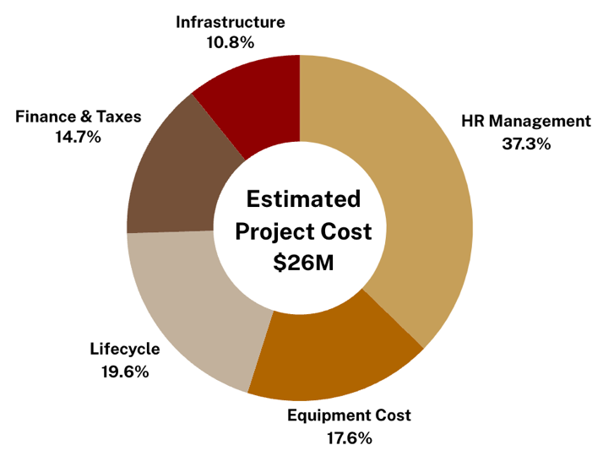

*Group wise % Spend Distribution*

The graph below illustrates the approach taken to achieve the 8.5% profit margin target. As observed in the graph, through the project's planning phase in FY23, we keep steady around 5% net profits. However, over the next 2 years as the project is executed and completed, we see a reduction in net profits, with some losses in FY25. As we resume full operations in FY26, we will begin to make greater profits and increase efficiency over the next seven years to meet our goal. Refer to *Appendix D* for a more complete breakdown of the budget and an elaborated calculations sheet of how we breakeven the investment costs by FY35.

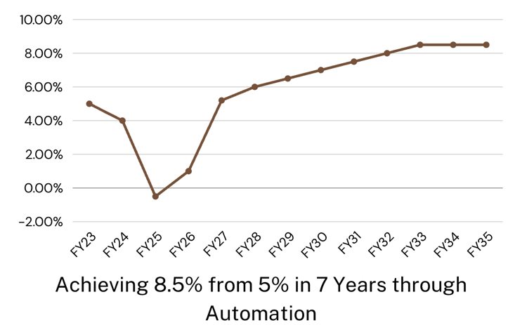

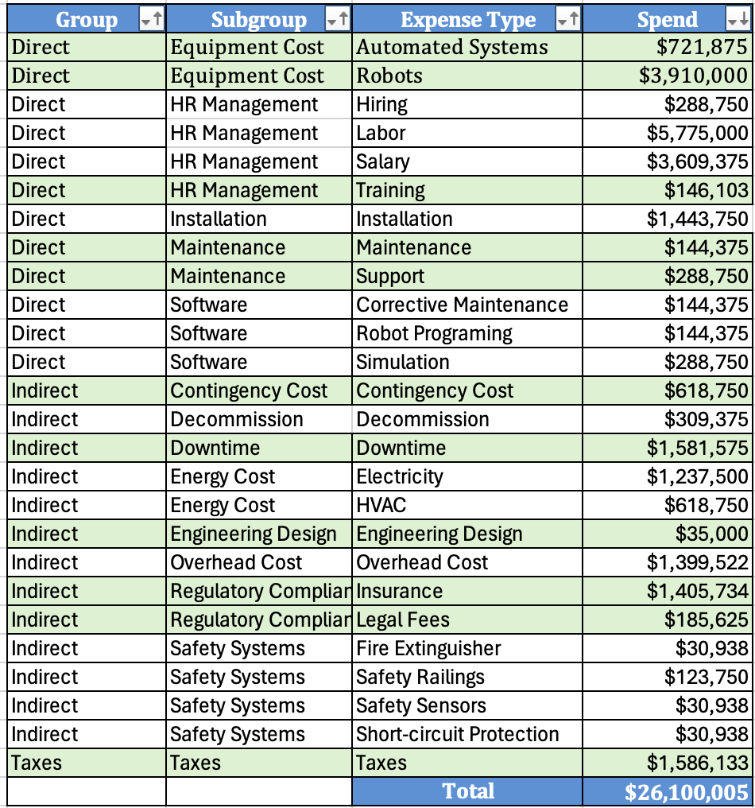

# **8.0 TEAM CREDENTIALS**

|  |  |
| --- | --- |
| Harish Bokka  NUID:002207413 bokka.h@northeastern.edu | Harish is a graduate student pursuing Engineering Management at Northeastern University. Prior to his graduate studies, Harish worked as a data analyst at a consulting firm for over two years, where he generated business insights for clients based on their ERP data. Harish is a product enthusiast who majored in mechanical engineering during his undergraduate studies. Additionally, he volunteered for many social campaigns and hosted cultural events during college. |
| Ruturaj Chavan  NUID: 002812057  chavan.ru@northeastern.edu | Ruturaj is a graduate student pursuing engineering management at Northeastern University. With an undergrad in mechanical engineering, he aims to work in the supply chain Industry leveraging his work experience as a procurement engineer in a manufacturing company. His skills include negotiation and team leadership showcased through several projects during his professional & education career. |
| Jayendra Deshmukh  NUID:002818865 deshmukh.j@northeastern.edu | Jayendra is a graduate student pursuing engineering management at Northeastern University. He completed his undergrad in electronics and telecommunication engineering and later went to work as a Associate Systems Engineer in Tata Consultancy Services. He is skilled in Python, Java, SQL, AWS and aims to work as a Product Manager. He is majorly interested in working in the startup ecosystem and wants to leverage his expertise to build sustainable solutions at scale. |
| Sanyam Sharma  NUID: 002812013  sharma.sanyam1@northeastern.edu | Sanyam is a graduate student pursuing Engineering Management at Northeastern University. Before commencing this program, he worked as a product owner for an automotive company for 4 years, where he focused on the design and development of autonomous parking systems. He is interested in pursuing his career in the field of product management since he has previous experience working in product-based organizations and possesses relevant skillsets to excel in this domain. |
| Mansi Patil  NUID: 002872664  patil.mansiy@northeastern.edu | Mansi is a graduate student currently pursuing a Master of Science in Engineering Management at Northeastern University. Mansi holds a bachelor’s degree in mechanical engineering from the University of Mumbai. With practical experience as a Project Manager Intern at both Newstech India Pvt Ltd and NCR Corporation. I am poised to leverage my skills and experiences to make valuable contributions in engineering and management domains. |
| Kush Patel (Point of Contact)  NUID: 002808574  patel.kush5@northeastern.edu | Kush is a graduate student pursuing master’s in engineering management at northeastern university. Kush worked as Project engineer at Cargill India pvt. ltd for 2.5 years before coming to USA. He aims to work for PMO team after completing higher education. He showcased his leadership and eloquent communication skills through the project and student clubs he led. |
| Aayushie Vairagade  NUID: 002895193  vairagade.a@northeastern.edu | Aayushie is an Engineering Management graduate student at Northeastern University with a robust background in cloud engineering and a keen interest in product management. With nearly three years of experience as a Cloud Engineer working on Microsoft Azure and an enriching stint in a product management internship, she has developed a deep appreciation for crafting solutions that meet market demands. She majored in Electronics and Telecommunications Engineering in her undergraduate studies. Currently she is enhancing her skills through participation in NEU's Aspiring Product Managers Club, she’s also passionate about theatre, which has honed her communication and teamwork abilities, complementing her tech-oriented career. |
| Bharath Vittal  NUID: 002846464  vittal.b@northeastern.edu | Bharath, an Engineering Management graduate student at Northeastern University, brings four years of data analysis and marketing experience in technology firms. Seeking a transition into Product Management, he possesses a strong passion for the field and is known for leading global teams in Fin-Tech, and Data Science industries. With proficiency in technology, sales, and marketing, Bharath is committed to driving growth and profitability in data-driven business environments. |

# **APPENDICES**

## **APPENDIX A: Work Breakdown Structure**

|  |  |
| --- | --- |
| **Task ID** | **Automotive Manufacturing Automation** |
| 1 | **1.0 Project Initiation** |
| 2 | 1.1 Kick-off Meeting |
| 3 | 1.1.1 Determine Project Scope Goals & Purpose |
| 4 | 1.1.2 Draft a communication plan |
| 5 | 1.2 Identify stakeholder & responsibilities |
| 6 | 1.3 Project Team Formation |
| 7 | **2.0 Project Planning Phase** |
| 8 | **2.1 Design & Engineering on every assembly line** |
| 9 | **Stage 1: 2.1.1 Welding** |
| 10 | **2.1.1.1 Mechanical Design** |
| 11 | 2.1.1.1.1 Understand work shell scope & identifying key parameters of robot |
| 12 | 2.1.1.1.2 Creating the layout concepts for the installation of robot |
| 13 | 2.1.1.1.4 Final iteration of designs for robot |
| 14 | **2.1.1.2 Civil Design** |
| 15 | 2.1.1.2.1 Designing the framework and foundation for robot installation as per robot's base |
| 16 | 2.1.1.2.2 Design civil structure for Control room |
| 17 | **2.1.1.3 Electrical & Instrument Design** |
| 18 | 2.1.1.3.1 Identify Robot's electrical requirements for welding |
| 19 | 2.1.1.3.2 Design electrical layout for welding |
| 20 | **2.1.1.4 HVAC Design** |
| 21 | 2.1.1.4.3 Design HVAC systems and modify existing system parameters for a new layout |
| 22 | **Stage 2: 2.1.2 Painting** |
| 23 | **2.1.2.1 Mechanical Design** |
| 24 | 2.1.2.1.1 Understand work shell scope & identifying key parameters of robot |
| 25 | 2.1.2.1.2 Creating the layout concepts for the installation of robot |
| 26 | 2.1.2.1.4 Final iteration of designs for robot |
| 27 | **2.1.2.2 Civil Design** |
| 28 | 2.1.2.2.1 Designing the framework and foundation for robot installation as per robot's base |
| 29 | 2.1.2.2.2 Design civil structure for Control room |
| 30 | **2.1.2.3 Electrical & Instrument Design** |
| 31 | 2.1.2.3.1 Identify Robot's electrical requirements for welding |
| 32 | 2.1.2.3.2 Design electrical layout for welding |
| 33 | **2.1.2.4 HVAC Design** |
| 34 | 2.1.2.4.3 Design HVAC systems and modify existing system parameters for a new layout |
| 35 | **Stage 3: 2.1.3 Windshield and Tire Assembly** |
| 36 | **2.1.3.1 Mechanical Design** |
| 37 | 2.1.3.1.1 Understand work shell scope & identifying key parameters of robot |
| 38 | 2.1.3.1.2 Creating the layout concepts for the installation of robot |
| 39 | 2.1.3.1.4 Final iteration of designs for robot |
| 40 | **2.1.3.2 Civil Design** |
| 41 | 2.1.3.2.1 Designing the framework and foundation for robot installation as per robot's base |
| 42 | 2.1.3.2.2 Design civil structure for Control room |
| 43 | **2.1.3.3 Electrical & Instrument Design** |
| 44 | 2.1.3.3.1 Identify Robot's electrical requirements for welding |
| 45 | 2.1.3.3.2 Design electrical layout for welding |
| 46 | **2.1.3.4 HVAC Design** |
| 47 | 2.1.3.4.3 Design HVAC systems and modify existing system parameters for a new layout |
| 48 | **2.2 Central control room** |
| 49 | 2.2.1 Selecting the location for control room and determining the elements requried for control room |
| 50 | 2.2.2 Designing the layout of control room as per equipment, personnel and space need |
| 51 | 2.2.3 Final iteration of designs |
| 52 | **2.3 Procurement Plan (Common across all the stages)** |
| 53 | 2.3.1 Develop procurement plan |
| 54 | 2.3.2 Vendors/suppliers for materials |
| 55 | **2.4 Defining workforce requirement** |
| 56 | 2.4.1 Identify the roles and responsibilities needed for the project |
| 57 | 2.4.2 Determine the number of personnel needed for each role |
| 58 | 2.4.3 Identify consultants and agencies needed for the project |
| 59 | 2.4.4 Estimate the hours required for each role |
| 60 | 2.4.5 Create a workforce budget |
| 61 | **2.5 Hiring Process** |
| 62 | 2.5.1 Determine the required roles within the team |
| 63 | 2.5.2 Identify number & nature of external hires |
| 64 | 2.5.3 Publish job openings |
| 65 | 2.5.4 Screen resumes |
| 66 | 2.5.5 Conduct interviews |
| 67 | 2.5.6 Make job offers and onboard new hires |
| 68 | **3.0 Project Execution Phase** |
| 69 | **3.1 Installation** |
| 70 | 3.1.1 Evaluate safety measures for all 3 stages |
| 71 | **3.1.2 Stage 1: Welding** |
| 72 | 3.1.2.1 Clearing site |
| 73 | 3.1.2.2 Land excavation |
| 74 | 3.1.2.3 Prepare foundation based on design |
| 75 | 3.1.2.4 Mechanical, Electrical & HVAC Work |
| 76 | 3.1.2.5 Installing robot on civil foundation |
| 77 | 3.1.2.6 Fastening & securing the robot onto the civil Foundation |
| 78 | 3.1.2.7 Installing electrical works and HVAC systems at pre-specified location as per design |
| 79 | 3.1.2.8 Install software packages as per design and modifications |
| 80 | 3.1.2.9 Calibrate robot for accurate and precise movements |
| 81 | 3.1.2.10 Installing sensors and vision system to align robot with conveyor belt |
| 82 | 3.1.2.11 Fixing machine guarding or safety fences around the robots |
| 83 | **3.1.3 Stage 2: Painting** |
| 84 | 3.1.3.1 Clearing site |
| 85 | 3.1.3.2 Land excavation |
| 86 | 3.1.3.3 Prepare foundation based on design |
| 87 | 3.1.3.4 Mechanical, Electrical & HVAC Work |
| 88 | 3.1.3.5 Installing robot on civil foundation |
| 89 | 3.1.3.6 Fastening & securing the robot onto the civil Foundation |
| 90 | 3.1.3.7 Installing electrical works and HVAC systems at pre-specified location as per design |
| 91 | 3.1.3.8 Install software packages as per design and modifications |
| 92 | 3.1.3.9 Calibrate robot for accurate and precise movements |
| 93 | 3.1.2.10 Installing sensors and vision system to align robot with conveyor belt |
| 94 | 3.1.2.11 Fixing machine guarding or safety fences around the robots |
| 95 | **3.1.4 Stage 3: Windshield and Tire Assembly** |
| 96 | 3.1.4.1 Clearing site |
| 97 | 3.1.4.2 Land excavation |
| 98 | 3.1.4.3 Prepare foundation and structural beam based on design |
| 99 | 3.1.4.4 Mechanical, Electrical & HVAC Work |
| 100 | 3.1.4.5 Installing robot on civil foundation |
| 101 | 3.1.4.6 Fastening & securing the robot onto the civil Foundation |
| 102 | 3.1.4.7 Mounting robotic arm |
| 103 | 3.1.4.8 Installing electrical works and HVAC systems at pre-specified location as per design |
| 104 | 3.1.4.9 Install software packages as per design and modifications |
| 105 | 3.1.4.10 Calibrate robot for accurate and precise movements |
| 106 | 3.1.2.11 Installing sensors and vision system to align robot with conveyor belt |
| 107 | 3.1.2.12 Fixing machine guarding or safety fences around the robotic structures |
| 108 | **3.2 Control Room Set-up (common for all control rooms)** |
| 109 | 3.2.1 Creating Ergonomic office set-up for user |
| 110 | 3.2.2 Unbox all equipment |
| 111 | 3.2.3 Clearing site and finishing civil work |
| 112 | 3.2.4 Install all equipment and configuring control room console for all robots and robotic arms |
| 113 | 3.2.5 Install software in console to control, monitor, program robot and robotic arms |
| 114 | **3.3 Testing and Commissioning (common for all stages)** |
| 115 | 3.3.1.1 Test integration between robot, HVAC, electrical systems |
| 116 | 3.3.1.2 Conduct penetration testing in control room |
| 117 | 3.3.1.3 Test control room-robot integration |
| 118 | 3.3.1.4 Conduct individual workstation testing of robots |
| 119 | 3.3.1.5 Ensure all safety regulations |
| 120 | 3.3.1.6 Address any issues or deficiencies discovered during preliminary testing |
| 121 | 3.3.1.7 Conduct site acceptance testing |
| 122 | 3.3.1.8 Commissioning the workstations |
| 123 | 3.3.1.9 Conduct trial runs at full capacity |
| 124 | **3.4 Training & Documentation (Common across all Stages)** |
| 125 | 3.4.1 SOP creation for daily operations and future maintenance |
| 126 | 3.4.2 SOP creation for safety procedures and emergency troubleshooting |
| 127 | 3.4.3 Conduct training for production staff on all procedures |
| 128 | **4.0 Project Closure Phase** |
| 129 | 4.1 Review project deliverables |
| 130 | 4.1.1 Obtain approval from stakeholders |
| 131 | 4.2 Closeout contracts with vendors and suppliers |
| 132 | 4.3 Setup an Operations and Maintenance team |
| 133 | 4.3.1 Handover to Operations and Maintenance team |
| 134 | 4.4 Conduct post-project review and document areas for improvement, best practices |
| 135 | 4.5 Final Project Report |

## **APPENDIX B: Project Schedule**

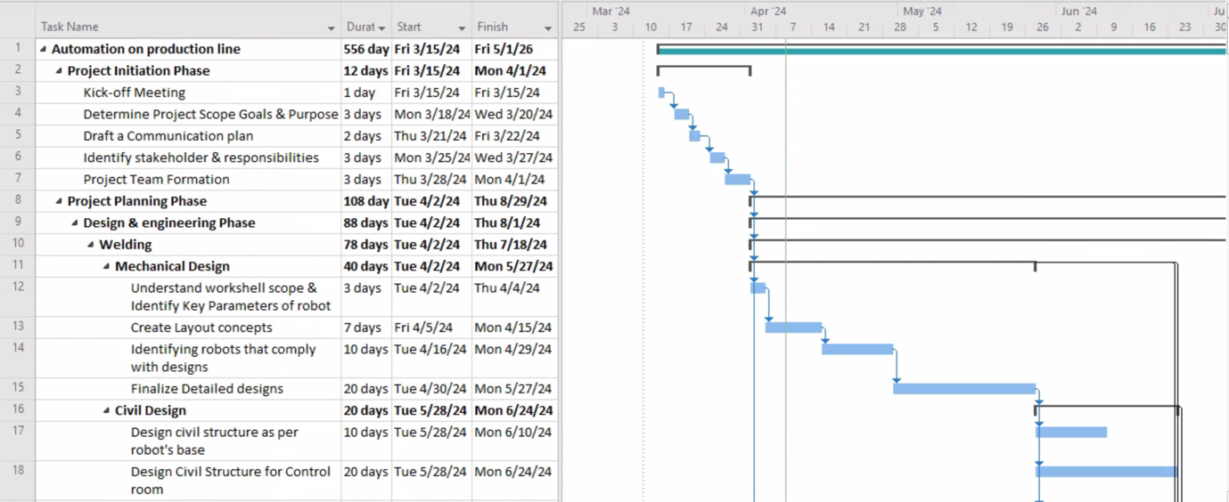

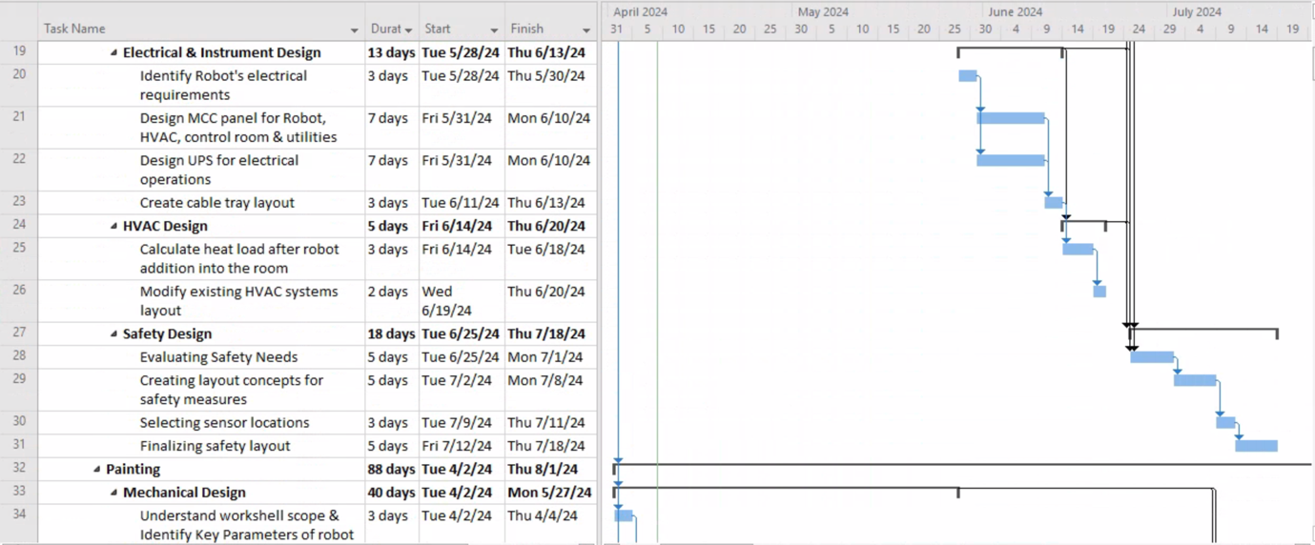

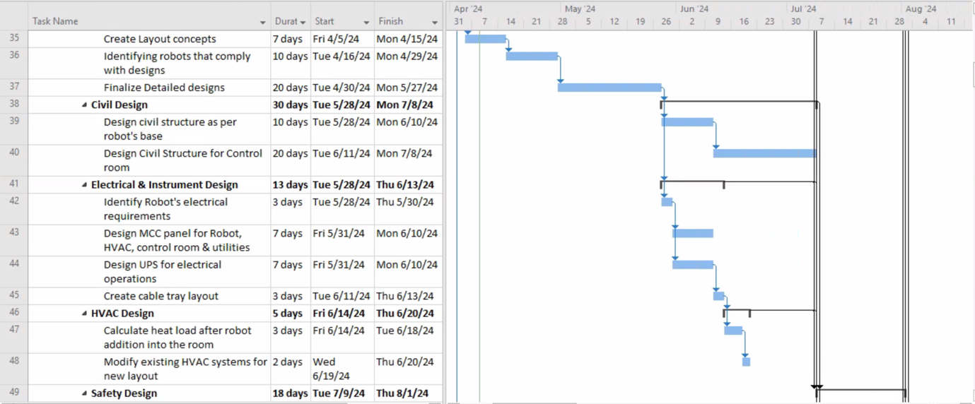

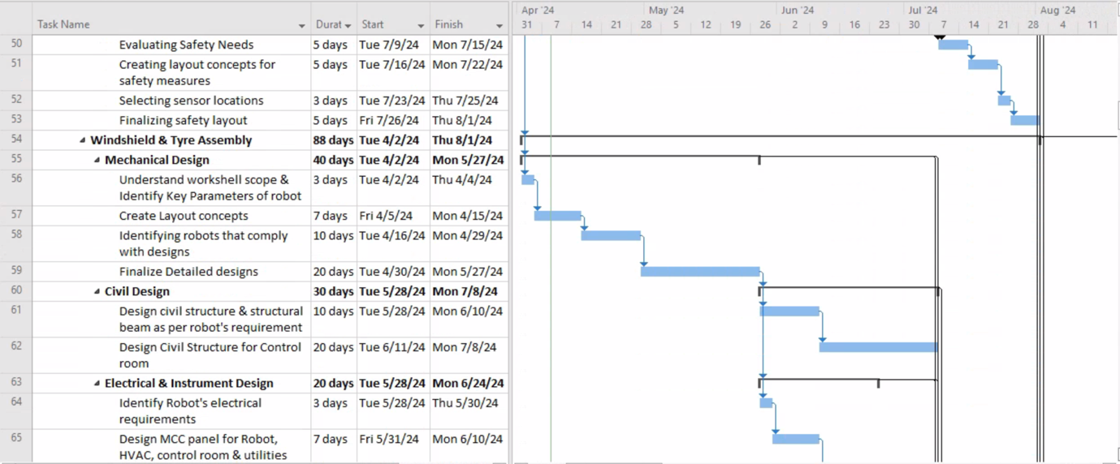

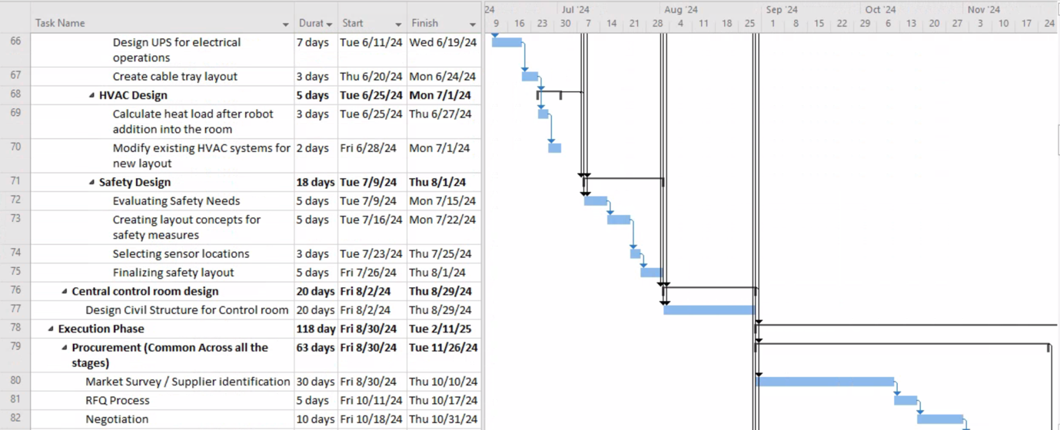

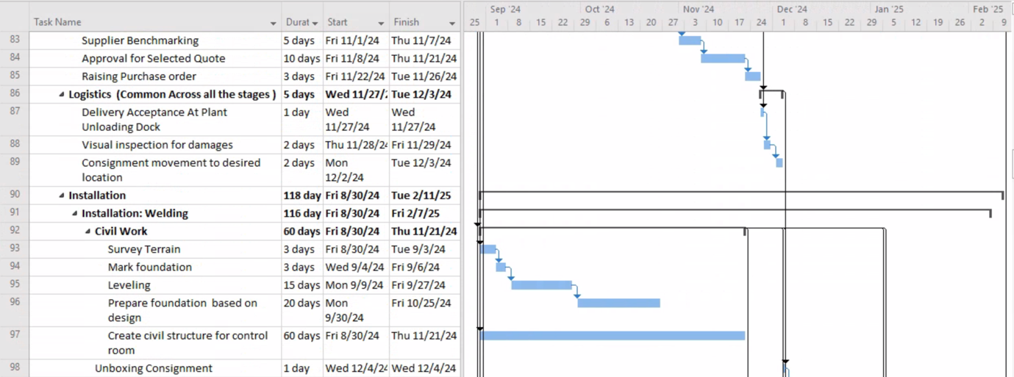

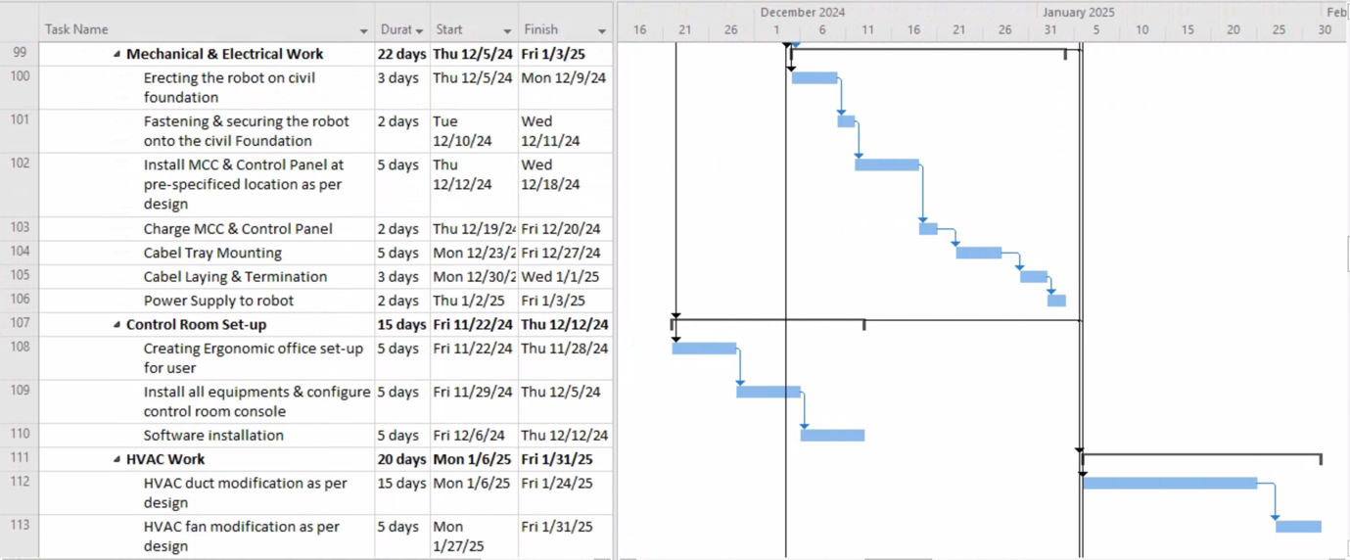

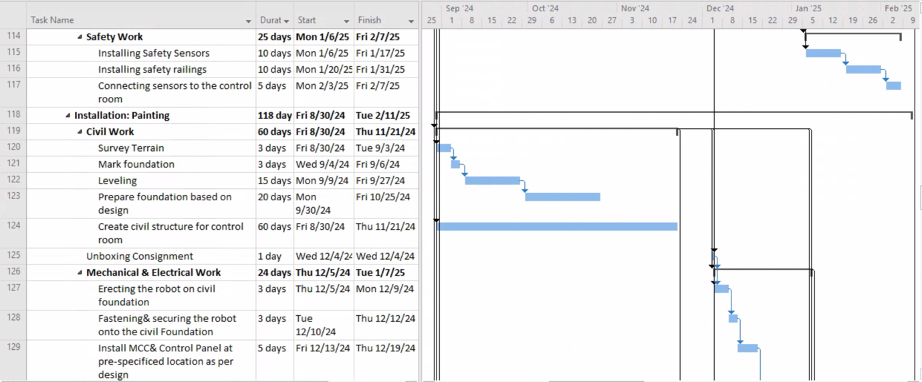

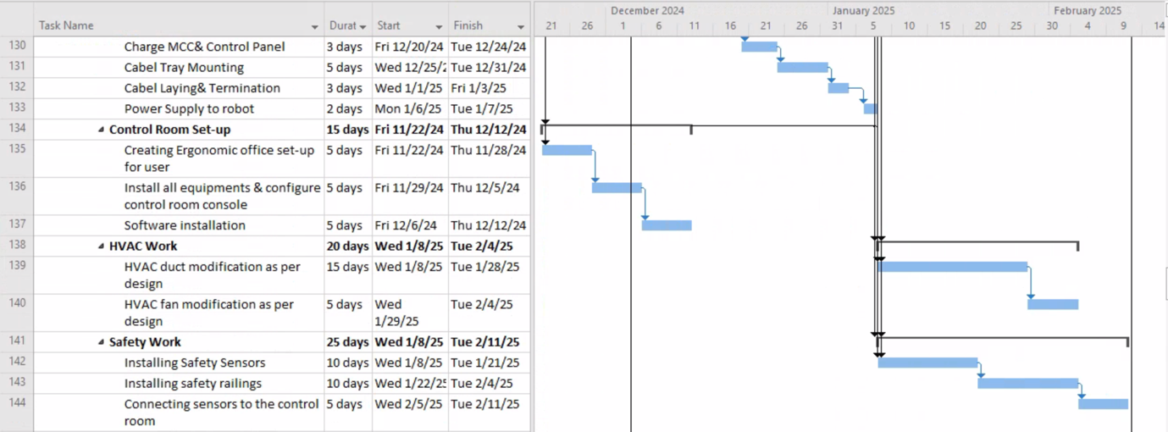

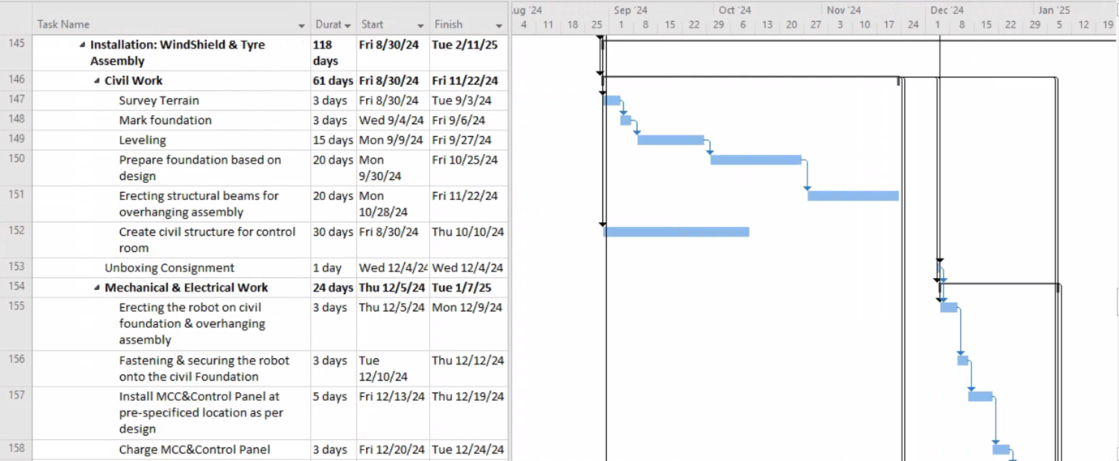

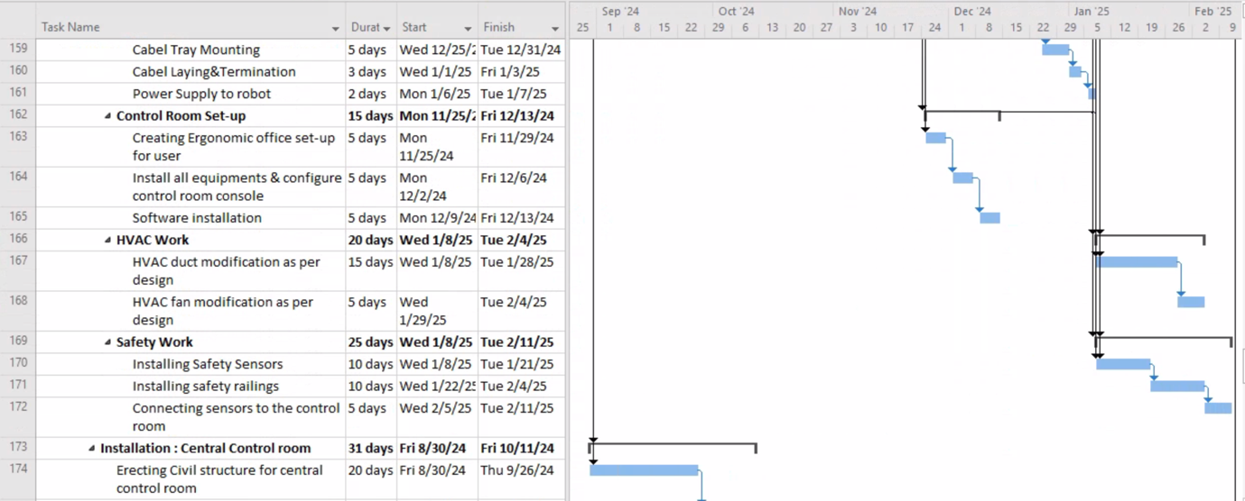

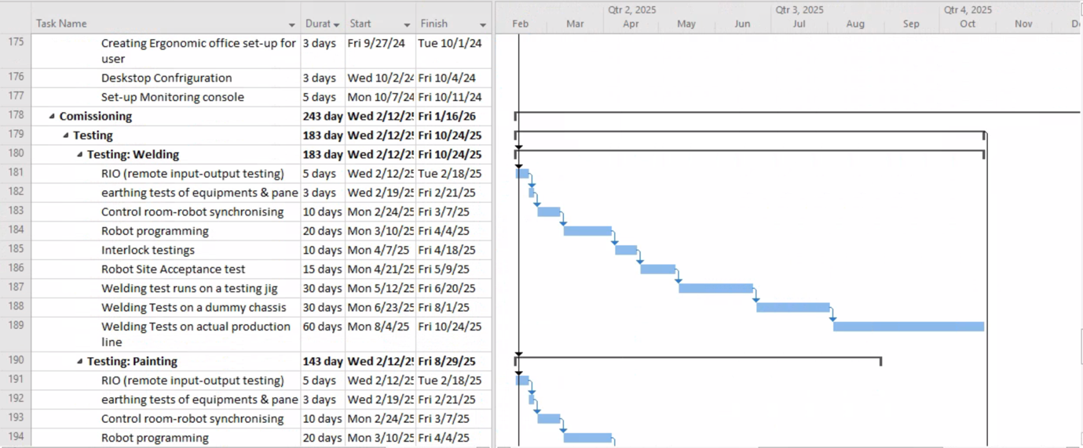

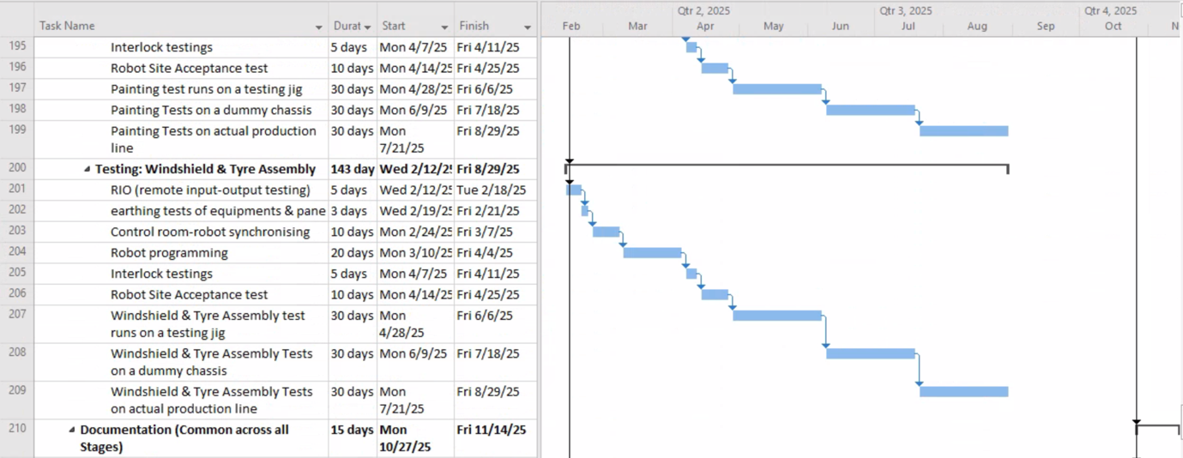

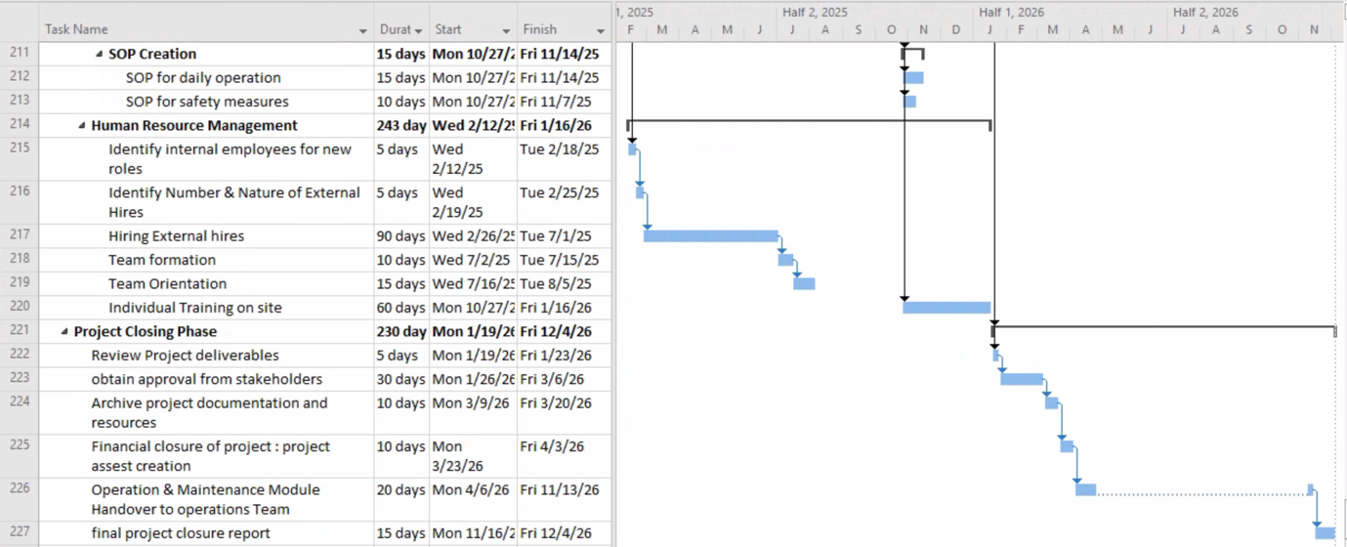

## **APPENDIX C: RACI Matrix**

|  |  |  |  |  |  |  |  |  |  |  |  |  |  |  |  |  |  |
| --- | --- | --- | --- | --- | --- | --- | --- | --- | --- | --- | --- | --- | --- | --- | --- | --- | --- |
|  | **Project Manager** | **Electrical Manager (Functional Manager)** | **Mechanical Manager (Functional Manager)** | **Civil Manager (Functional Manager)** | **Electrical Engineer** | **Mechanical Engineer** | **Civil Engineer** | **Electrical Designer** | **Mechanical Designer** | **Civil Designer** | **Procurement Manager** | **Safety Manager** | **Financial Manager** | **Supplier/Vendor** | **HR Manager** | **Software Manager** | **Maintenance Manager** |
| 1.0 Project Initiation |  |  |  |  |  |  |  |  |  |  |  |  |  |  |  |  |  |
| 1.1 Discussing project goal, scope and purpose | R,A | C | C | C | I | I | I | I | I | I | I | I | C |  | I | I | I |
| 1.2 Creating different teams for project | R,A | C | C | C | I | I | I | I | I | I | I | I | I |  | I | I |  |
| 2.0 Welding Workstation Design |  |  |  |  |  |  |  |  |  |  |  |  |  |  |  |  |  |
| 2.1 Mechanical Design | I |  | A |  |  |  |  |  | R |  |  | C |  |  |  |  |  |
| 2.2 Civil Design | I |  |  | A |  |  |  |  |  | R |  | C |  |  |  |  |  |
| 2.3 Electrical & Instrument Design | I | A |  |  |  |  |  | R |  |  |  | C |  |  |  |  |  |
| 2.4 HVAC Design | I |  | A |  |  |  |  |  | A |  |  | C |  |  |  |  |  |
| 3.0 Painting Workstation Design |  |  |  |  |  |  |  |  |  |  |  |  |  |  |  |  |  |
| 3.1 Mechanical Design | I |  | A |  |  |  |  |  | R |  |  | C |  |  |  |  |  |
| 3.2 Civil Design | I |  |  | A |  |  |  |  |  | R |  | C |  |  |  |  |  |
| 3.3 Electrical & Instrument Design | I | A |  |  |  |  |  | R |  |  |  | C |  |  |  |  |  |
| 3.4 HVAC Design | I |  | A |  |  |  |  |  | A |  |  | C |  |  |  |  |  |
| 4.0 Windshield & Tire Assembly Design |  |  |  |  |  |  |  |  |  |  |  |  |  |  |  |  |  |
| 4.1 Mechanical Design | I |  | A |  |  |  |  |  | R |  |  | C |  |  |  |  |  |
| 4.2 Civil Design | I |  |  | A |  |  |  |  |  | R |  | C |  |  |  |  |  |
| 4.3 Electrical & Instrument Design | I | A |  |  |  |  |  | R |  |  |  | C |  |  |  |  |  |
| 4.4 HVAC Design | I |  | A |  |  |  |  |  | A |  |  | C |  |  |  |  |  |

|  |  |  |  |  |  |  |  |  |  |  |  |  |  |  |  |  |  |
| --- | --- | --- | --- | --- | --- | --- | --- | --- | --- | --- | --- | --- | --- | --- | --- | --- | --- |
|  | **Project Manager** | **Electrical Manager (Functional Manager)** | **Mechanical Manager (Functional Manager)** | **Civil Manager (Functional Manager)** | **Electrical Engineer** | **Mechanical Engineer** | **Civil Engineer** | **Electrical Designer** | **Mechanical Designer** | **Civil Designer** | **Procurement Manager** | **Safety Manager** | **Financial Manager** | **Supplier/Vendor** | **HR Manager** | **Software Manager** | **Maintenance Manager** |
| 5.0 Procurement Plan |  |  |  |  |  |  |  |  |  |  |  |  |  |  |  |  |  |
| 5.1 Market Survey / Supplier identification | I |  |  |  |  |  |  |  |  |  | R,A |  | C |  |  |  |  |
| 5.2 RFQ Process | A |  |  |  |  |  |  |  |  |  | R |  | C |  |  |  |  |
| 5.3 Negotiation | A |  |  |  |  |  |  |  |  |  | R |  | C | I |  |  |  |
| 5.4 Supplier Benchmarking | A |  |  |  |  |  |  |  |  |  | R |  | C |  |  |  |  |
| 5.5 Approval for Selected Quote | A |  |  |  |  |  |  |  |  |  | I |  | R |  |  |  |  |
| 5.6 Raising Purchase order | A |  |  |  |  |  |  |  |  |  | R |  | C | I |  |  |  |
| 6.0 Logistics Plan |  |  |  |  |  |  |  |  |  |  |  |  |  |  |  |  |  |
| 6.1 Delivery Acceptance at Plant Unloading Dock | A |  |  |  |  |  |  |  |  |  | R |  |  |  |  |  |  |
| 6.2 Visual inspection for damages | A |  |  |  |  |  |  |  |  |  | R |  |  |  |  |  |  |
| 6.3 Consignment movement to desired location | A |  |  |  |  |  |  |  |  |  | R |  |  |  |  |  |  |
| 7.0 Defining Workforce Requirement |  |  |  |  |  |  |  |  |  |  |  |  |  |  |  |  |  |
| 7.1 Identify roles and responsibilities needed | A |  |  |  |  |  |  |  |  |  |  |  |  |  | R |  |  |
| 7.2 Determine the number of personnel needed | A |  |  |  |  |  |  |  |  |  |  |  |  |  | R |  |  |
| 7.3 Identify consultants and agencies needed | A |  |  |  |  |  |  |  |  |  |  |  | C |  | R |  |  |
| 7.4 Estimate the hours required for each role | R,A |  |  |  |  |  |  |  |  |  |  |  | C |  |  |  |  |
| 7.5 Create a workforce budget | A |  |  |  |  |  |  |  |  |  |  |  | R |  | C |  |  |

|  |  |  |  |  |  |  |  |  |  |  |  |  |  |  |  |  |  |
| --- | --- | --- | --- | --- | --- | --- | --- | --- | --- | --- | --- | --- | --- | --- | --- | --- | --- |
|  | **Project Manager** | **Electrical Manager (Functional Manager)** | **Mechanical Manager (Functional Manager)** | **Civil Manager (Functional Manager)** | **Electrical Engineer** | **Mechanical Engineer** | **Civil Engineer** | **Electrical Designer** | **Mechanical Designer** | **Civil Designer** | **Procurement Manager** | **Safety Manager** | **Financial Manager** | **Supplier/Vendor** | **HR Manager** | **Software Manager** | **Maintenance Manager** |
| 7.6 Publish job openings | A, C | C | C | C |  |  |  | A | I | R |  |  |  |  | R |  |  |
| 7.7 Conduct interviews | A | C | C | C |  |  |  | A | I | R |  |  |  |  | R |  |  |
| 7.8 Make job offers and onboard new hires | A | C | C | C |  |  |  | A | I | R |  |  | C |  | R |  |  |
| 8.0 Installation (For all 3 stages) |  |  |  |  |  |  |  |  |  |  |  |  |  |  |  |  |  |
| 8.1 Evaluate safety measures for all 3 stages | I | A | A | A |  |  |  |  |  |  |  | R, A |  |  |  |  |  |
| 8.2 Unboxing consignment | I |  |  |  |  |  |  |  |  |  | R, A |  |  |  |  |  |  |
| 8.3 Clearing site | I |  |  | A |  |  | R |  |  |  |  | C |  |  |  |  |  |
| 8.4 Land excavation | I |  |  | A |  |  | R |  |  |  |  | C |  |  |  |  |  |
| 9.5 Prepare foundation and structural beam based on design | I |  |  |  |  |  | R |  |  |  |  | C |  |  |  |  |  |
| 9.6 Installing robot on civil foundation | I |  | A |  |  | R |  |  |  |  |  | C |  |  |  |  |  |
| 9.7 Fastening & securing the robot | I |  |  |  |  |  |  |  |  |  |  | C |  |  |  |  |  |
| 9.8 Installing electrical works and HVAC systems at pre-specified location as per design | I | A | A |  | R | R |  |  |  |  |  | C |  |  |  |  |  |
| 10.0 Preparation of Control Rooms |  |  |  |  |  |  |  |  |  |  |  |  |  |  |  |  |  |
| 10.1 Site excavation | I |  |  | A |  |  | R |  |  | A |  |  |  |  |  |  |  |
| 10.2 Construction of control rooms | I |  |  | A |  |  | R |  |  | A |  |  |  |  |  |  |  |
| 10.3 Unboxing equipment for control rooms | I |  |  |  |  |  |  |  |  |  | R, A |  |  |  |  |  |  |
|  | **Project Manager** | **Electrical Manager (Functional Manager)** | **Mechanical Manager (Functional Manager)** | **Civil Manager (Functional Manager)** | **Electrical Engineer** | **Mechanical Engineer** | **Civil Engineer** | **Electrical Designer** | **Mechanical Designer** | **Civil Designer** | **Procurement Manager** | **Safety Manager** | **Financial Manager** | **Supplier/Vendor** | **HR Manager** | **Software Manager** | **Maintenance Manager** |
| 10.4 Installing equipment for control rooms | I |  | A |  |  | R |  |  |  |  |  | C |  |  |  |  |  |
| 10.5 Installing electrical work and HVAC systems for control rooms | I | A |  |  | R |  |  |  |  |  |  | C |  |  |  |  |  |
| 10.6 Install software packages as per design and modifications | I |  |  |  |  |  |  |  |  |  |  |  |  |  |  | R, A |  |
| 10.7 Fixing machine guarding or safety fences around the robots | I | C | C | C |  |  |  |  |  |  |  | R, A |  |  |  |  |  |
| 11.0 Testing |  |  |  |  |  |  |  |  |  |  |  |  |  |  |  |  |  |
| 11.1 Test integration between robot, HVAC, electrical systems | I | A | A |  | R | R |  |  |  |  |  | C |  |  |  |  |  |
| 11.2 Conduct penetration testing in control room | I |  |  |  |  |  |  |  |  |  |  |  |  |  |  | R | A |
| 11.3 Test control room-robot integration | I | R | R | R |  |  |  |  |  |  |  |  |  |  |  | R | A |
| 11.4 Conduct individual workstation testing of robots | I | R | R | R |  |  |  |  |  |  |  |  |  |  |  |  | A |
| 11.5 Ensure all safety regulations | A | I | I | I |  |  |  |  |  |  |  | R |  |  |  |  |  |
| 11.6 Address any issues or deficiencies discovered during preliminary testing | I | R | R | R |  |  |  |  |  |  |  | C |  |  |  |  | A |
| 11.7 Conduct site acceptance testing | A | R | R | R |  |  |  |  |  |  |  | I |  |  |  | R | I |
| 11.8 Commissioning the workstations | A | C | C | C |  |  |  |  |  |  |  |  |  |  |  |  | R |

|  |  |  |  |  |  |  |  |  |  |  |  |  |  |  |  |  |  |
| --- | --- | --- | --- | --- | --- | --- | --- | --- | --- | --- | --- | --- | --- | --- | --- | --- | --- |
|  | **Project Manager** | **Electrical Manager (Functional Manager)** | **Mechanical Manager (Functional Manager)** | **Civil Manager (Functional Manager)** | **Electrical Engineer** | **Mechanical Engineer** | **Civil Engineer** | **Electrical Designer** | **Mechanical Designer** | **Civil Designer** | **Procurement Manager** | **Safety Manager** | **Financial Manager** | **Supplier/Vendor** | **HR Manager** | **Software Manager** | **Maintenance Manager** |
| 11.9 Conduct trial runs at full capacity | R, A |  |  |  |  |  |  |  |  |  |  |  |  |  |  |  |  |
| 12.0 Training & Documentation |  |  |  |  |  |  |  |  |  |  |  |  |  |  |  |  |  |
| 12.1 Develop training materials | R, A | C | C | C |  |  |  |  |  |  |  | C | C |  |  | C | C |
| 12.2 Conduct training sessions | R, A |  |  |  |  |  |  |  |  |  |  |  |  |  | I |  |  |
| 12.3 Create user manuals | R, A | C | C | C |  |  |  |  |  |  |  |  |  |  |  |  |  |
| 13.0 Project Closure Phase |  |  |  |  |  |  |  |  |  |  |  |  |  |  |  |  |  |
| 13.1 Review project deliverables | R, A | C | C | C |  |  |  |  |  |  | C | C | C |  | C | C | C |
| 13.2 Closeout contracts with vendors and suppliers | R, A |  |  |  |  |  |  |  |  |  | I |  | C | C |  |  |  |
| 13.3 Setup Operations and Maintenance team | R, A | C | C | C |  |  |  |  |  |  |  |  | I |  | I |  | C |
| 13.4 Conduct post-project review and document areas for improvement, best practices | R, A | C | C | C | C | C | C | C | C | C | C | C | C | C | C | C | C |
| 13.5 Final Project Review | R, A | I | I | I | I | I | I | I | I | I | I | I | I | I | I | I | I |

## **APPENDIX D: Financial Budget**

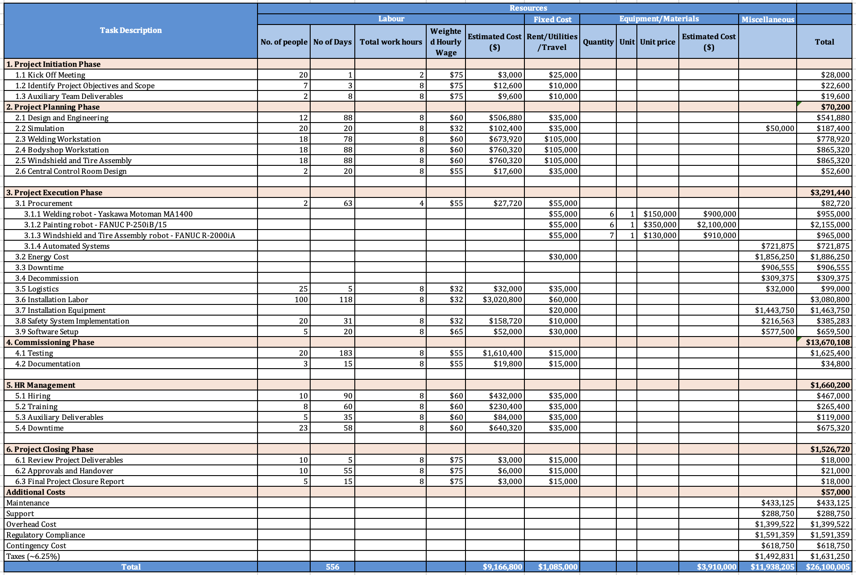

*Budget Breakdown*

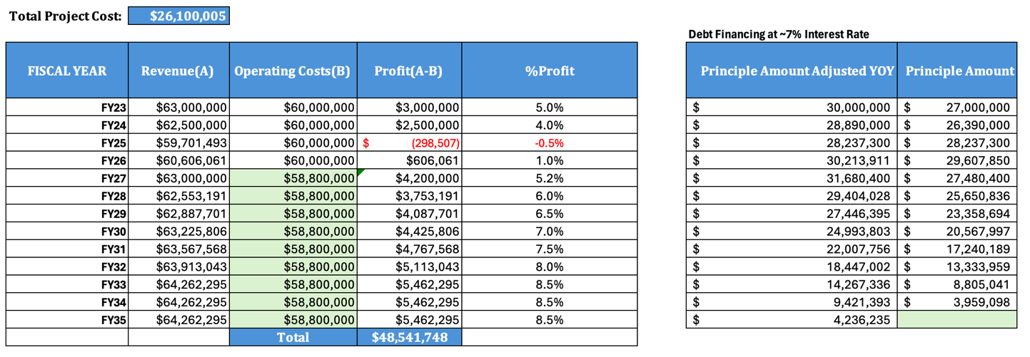

*Cost Benefit Analysis to breakeven on investments*

*Assumptions Made:*

1. *We use the entire profits up against the loan amount*
2. *We Finance the investment at ~7% ROI*

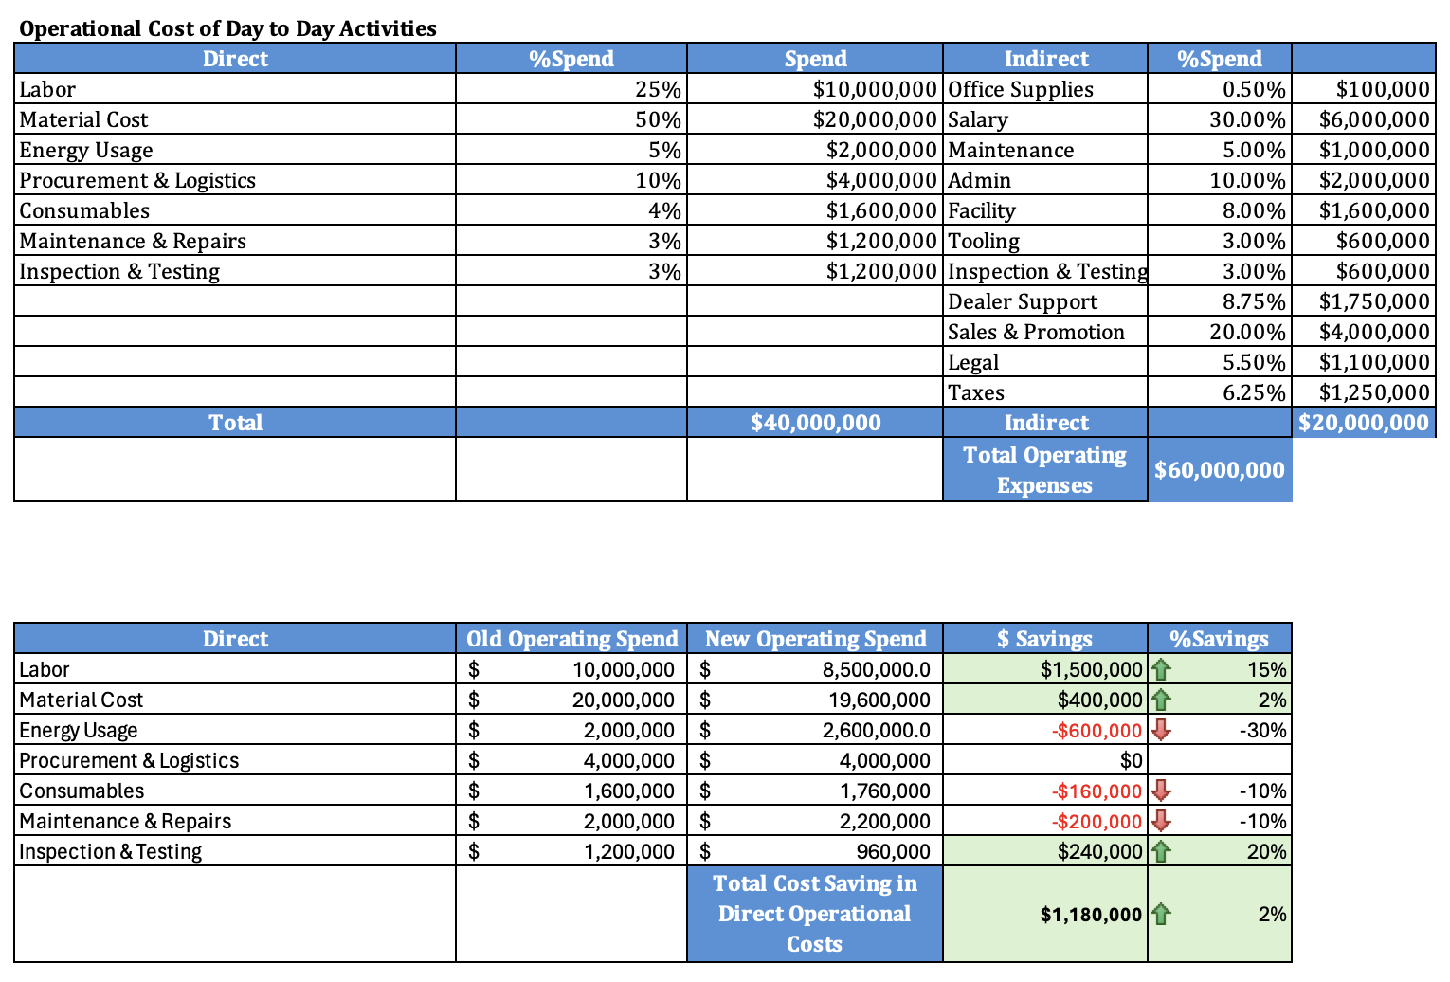

*Operational Cost of Day-to-Day Activities*

## **APPENDIX E: Resource Allocation**

|  |  |  |  |  |  |  |  |
| --- | --- | --- | --- | --- | --- | --- | --- |
| **Designation / Weeks** | **Week**  **1 - 2** | **Week**  **3 - 8** | **Week**  **9 - 13** | **Week 14 -15** | **Week 16** | **Week 17 - 19** | **Week 20 - 22** |
| Project Manager | 100% | 90% | 80% | 80% | 80% | 80% | 80% |
| Mechanical Design Engineers | 10% | 100% |  |  | 100% | 100% | 100% |
| Electrical Design Engineers | 10% |  |  | 100% | 100% | 100% | 100% |
| Civil Design Engineers | 10% |  | 100% |  |  |  | 100% |
| Procurement Team Representative | 10% |  |  |  |  |  |  |
| Logistics Team Representative | 10% |  |  |  |  |  |  |
| Site Mechanical Engineers |  |  |  |  |  |  |  |
| Site Electrical Engineers |  |  |  |  |  |  |  |
| Site Civil Engineers |  |  |  |  |  |  |  |
| OEM Engineers |  |  |  |  |  |  |  |
| Functional Manager (Engineering Team Manager) | 50% | 40% | 40% | 40% | 40% | 40% | 40% |
| Financial Manager | 20% |  |  |  |  |  |  |
| Operation Department Manager | 80% | 50% | 50% | 50% | 50% | 50% | 50% |
| Maintenance Manager | 10% |  |  |  |  |  |  |
| Safety / EHS Manager | 10% |  |  |  |  | 100% |  |
| HR Manager | 10% |  |  |  |  |  |  |

|  |  |  |  |  |  |  |  |
| --- | --- | --- | --- | --- | --- | --- | --- |
| **Designation / Weeks** | **Week 23 - 25** | **Week 26 - 28** | **Week 29 - 31** | **Week 32 - 34** | **Week 35 - 37** | **Week 38 - 39** | **Week 40 - 42** |
| Project Manager | 50% | 50% | 50% | 50% | 50% | 50% | 50% |
| Mechanical Design Engineers | 40% | 40% | 40% | 20% | 10% |  |  |
| Electrical Design Engineers | 40% | 40% | 40% | 20% | 10% |  |  |
| Civil Design Engineers | 40% | 40% | 40% | 20% | 10% |  |  |
| Procurement Team Representative | 100% | 100% | 100% | 80% |  |  |  |
| Logistics Team Representative |  |  | 70% | 100% |  |  |  |
| Site Mechanical Engineers |  |  |  | 40% | 100% | 100% | 100% |
| Site Electrical Engineers |  |  |  | 40% | 100% | 100% | 100% |
| Site Civil Engineers | 80% | 100% | 100% | 100% | 100% |  |  |
| OEM Engineers | 100% | 100% | 100% | 100% | 100% |  |  |
| Functional Manager (Engineering Team Manager) | 30% | 30% | 30% | 30% | 40% | 40% | 40% |
| Financial Manager |  |  |  |  |  |  |  |
| Operation Department Manager | 20% | 20% | 20% | 20% | 20% | 20% | 20% |
| Maintenance Manager |  |  |  |  |  |  |  |
| Safety / EHS Manager | 60% | 60% | 60% | 60% | 60% | 60% | 60% |

|  |  |  |  |  |  |
| --- | --- | --- | --- | --- | --- |
| **Designation / Weeks** | **Week 43 - 45** | **Week 46 - 83** | **Week 84 - 98** | **Week**  **99 - 100** | **Week 101 -111** |
| Project Manager | 50% | 40% | 40% | 40% | 100% |
| Mechanical Design Engineers |  | 10% |  | 50% | 20% |
| Electrical Design Engineers |  | 10% |  | 50% | 20% |
| Civil Design Engineers |  | 10% |  | 50% | 20% |
| Procurement Team Representative |  |  |  |  | 30% |
| Logistics Team Representative |  |  |  |  | 30% |
| Site Mechanical Engineers | 100% | 100% | 100% |  | 20% |
| Site Electrical Engineers | 100% | 100% | 100% |  | 20% |
| Site Civil Engineers | 100% | 100% | 100% |  | 20% |
| OEM Engineers | 100% | 100% | 100% |  | 40% |
| Functional Manager (Engineering Team Manager) | 40% | 50% | 50% | 50% | 20% |
| Financial Manager |  |  |  |  | 100% |
| Operation Department Manager | 20% | 80% | 80% | 100% | 100% |
| Maintenance Manager |  |  |  | 100% | 100% |
| Safety / EHS Manager | 100% | 75% | 75% | 10% |  |
| HR Manager |  | 100% | 100% |  |  |

1. TWS, "Does the Auto Industry Still Need Welders?" <https://www.tws.edu/blog/welding/does-the-auto-industry-still-need-welders/>
2. # Robots in Automotive Manufacturing: Painting and Finishing <https://www.azorobotics.com/Article.aspx?ArticleID=639>

  
3. # American Torch Tip, "How Welding Robots Can Decrease Your Costs and Boost Your Productivity" <https://americantorchtip.com/blog/how-welding-robots-can-decrease-your-costs-and-boost-your-productivity/>

  
4. Robotics and Automation News “Automotive robotics market forecast to be worth almost $6 billion by 2024”<https://roboticsandautomationnews.com/2017/08/31/automotive-robotics-market-forecast-to-be-worth-almost-6-billion-by-2024/13920/>
5. Deskera “Role of Automation in Manufacturing” <https://www.deskera.com/blog/role-of-automation-in-manufacturing/>
6. Industrial Revolution. 4.0 <https://en.wikipedia.org/wiki/Fourth_Industrial_Revolution>
7. Robots.com “Motoman MA 1400” <https://www.robots.com/industrial-robots/motoman-ma1400>
8. XUM Miniature Photoelectric Sensor <https://www.newark.com/pdfs/techarticles/squareD/004.pdf>
9. FANUC P-250iB <https://www.fanucamerica.com/products/robots/series/paint/p-250ib-paint-robot>
10. Fanuc Robot Controller <https://www.fanucamerica.com/products/robots/controllers>
11. FANUC 2000iB/200T <https://www.fanucamerica.com/products/robots/series/r-2000/r-2000ib-200t-toploader-robot>
12. FANUC M-710iC/50T <https://www.fanucamerica.com/products/robots/series/m-710/m-710ic-50t-toploader-robot>
13. FANUC R2000iC <https://www.fanuc.com/fvl/vn/product/catalog/RR-2000iC(E)-06.pdf>
14. American National Standard for Industrial Robots and Robot Systems (ANSI/RIA R15.06-2012) <https://webstore.ansi.org/standards/ria/ansiriar15062012>
15. ISO Technical Specification ISO/TS 15066:2016 <https://www.iso.org/standard/62996.html#:~:text=ISO%2FTS%2015066%3A2016%20specifies,1%20and%20ISO%2010218%E2%80%912>
16. Glassdoor <https://www.glassdoor.com/Community/index.htm>